

**Course**

Business Innovation and International

Information Technology Management

Birkbeck University

**Robert Tombs**

**13156308**

**2019/2020**

**Thesis to discuss the question;**

Technical Unemployment, can it be different this time? - The perception of employees on the changes to their jobs caused by technology.

Word count 12,804

Word limit 12,000

Contents

**1.** **Abstract** 4

**2.** **Acknowledgements** 5

**3.** **Introduction** 6

3.1 Brief background to the subject 6

3.2 Why the study is important/relevant 7

3.3 What is the research problem 9

3.4 Practical & theoretical significance 10

**4.** **Research literature** 11

4.1 Introduction 11

4.2 What is technological unemployment 11

4.2.1 Keynes original meaning 11

4.3 Occupations, tasks & threats 14

4.3.1 Occupations & tasks 14

4.3.2 Threats 16

4.4 Perceptions and anxiety 18

4.4.1 Source of perception & anxiety 19

4.5 The Hypotheses 23

**5.** **Research questions & methods** 25

5.1 Research objectives 25

5.2 Methodology structure & Research design 26

5.3 Measures 28

5.4 Data collection 29

5.5 Description of data 30

5.6 Research Ethics 31

**6.** **Analysis** 33

6.1 Pearson Correlation Matrix 33

6.2 Descriptive statistics 34

6.2.1 Hypothesis 1 34

6.2.2 Hypothesis 2 44

6.2.3 Hypothesis 3 53

**7.** **Discussions & Critique** 60

7.1 Why do the results matter? 64

7.2 Limitations: what can’t the results tell us? 65

7.3 What practical actions or scientific studies should follow? 66

**8.** **Summary / Conclusion** 67

**9.** **Bibliography** 71

**10.** **Appendices** 77

10.1 Appendix 1 - Dissertation Proposal 77

10.2 Appendix 2 – Research Log 90

10.3 Appendix 3 - Ethics Review 91

10.4 Appendix 4 - Data Models 108

10.5 Appendix 5 - Data collection records 110

10.5.1 Qualtric responses 111

10.5.2 Number of completed and uncompleted surveys 111

10.6 Appendix 6 – Raw data (Quantitative) 112

10.7 Appendix 7 - Data analysis 122

10.8 Appendix 8 – Pearson Correlation Matrix 164

# **Abstract**

It has long been considered that technological automation replaces workers jobs, however, recent studies imply that the job is not replaced, rather the tasks or sets of tasks that an employee may do as part of his or her day-to-day job are being replaced through automation.

This automation of tasks can give rise to the employee’s perception that their job security is under threat. As job security is a subjective phenomenon, this research utilises cross-sectional surveys to collect quantitative data that, when tested will indicate any correlation between recent technological automation of tasks, or current / future planned technological automation of tasks, and employees perceived job security.

Technical unemployment can be an emotive subject and the threat could be the cause of concern and anxiety to employees engaged in providing for themselves and their families within any economy. Through the question*“Technical unemployment, can it be different this time? - The perception of employees on the changes to their jobs caused by technological automation”*, this study has examined previous research into technological automation where a gap has been identified that little research has been completed into the perceptions an employee may have about technological automation where it impacts their specific role and employment circumstances.

Historically, research to date has investigated the physical act of replacing an occupation, a job, a task or set of tasks, and or the possible impacts of those actions on the organisation and its capabilities, but little research has studied employees perceptions of technological automation, and how those perceptions could impact on them, their families and the organisation.

# **Acknowledgements**

I would like to thank the following people for their assistance in assembling this research.

Ms Angie McCormick for setting me off on the pleasurable and painful journey, and for which I will be forever in your debt, I will forever miss you, your wisdom and humour and grace. Dr Marion Frenz who was my University Supervisor; and Ms Louise Sammé for reading, checking and being my confidant when trying to work my way through the many rabbit holes I ventured down.

# **Introduction**

We as a society live in tandem with technology, in all of its forms; from the humble toaster, tablet computer, smartphones, voice-controlled televisions, AlexaTM and smartwatches, through to the driverless car. Although there may be little research on how the electric toaster impacted on making the breakfast meal, there is research on how computers and robots have automated tasks within the workplace and how the driverless car could improve safety on the world's roads. The question*“Technical unemployment, can it be different this time? - The perception of employees on the changes to their jobs caused by technological automation”*, proposes hypotheses that can be used to examine employees perception of tasks they perform as part of their role within an organisation being automated within the white-collar office environment.

## 3.1 Brief background to the subject

(Keynes, 1931) was one of the first to propose that technological automation was occurring within the workplace citing in a seminal paper that “technological advances have also resulted in the reduction of labour within the workplace”. By using Technological Unemployment as defined by Keynes (1931), as an introduction to the technological automation of jobs and occupations the majority of research carried out to date is still using the dimensions established by Keynes as a foundation and has centred on the physical replacement of the task or group of tasks completed by the employee.

Early adopters of technological automation created momentous impacts on the obsoletion of some occupations historically. To date the physical attributes associated with the occupation have been utilised in research as indicators that the occupation could become obsolete through technological automation. However technological automation academic studies, research and development have moved from the occupation obsoletion to the automation of tasks and groups of tasks.

## 3.2 Why the study is important/relevant

Technical unemployment is an emotive subject and the threat can be the cause of concern and anxiety to employees engaged in providing for themselves and their families within any economy. Historically research has investigated the physical act of replacing a job, a task, a group of tasks, an occupation, or the impacts of that automation on the organisation and the structure required to support the technological automation. However, few studies have considered the employee and the perception they may have regarding the use of technological automation or the increasing use of automation within the office workplace, or how it could impact them, and their job within the organisation. This study could be seen as important, as employee perceptions can give rise to changes in employee behaviour motivation, possibly effecting organisational capabilities, information sharing and innovation, as well as possibly impacting the employee’s family relations, self-worth and financial viability.

Comparable research questions (Iverson, 1996; Lissitsa and Chachashvili-Bolotin, 2016),(Mokyr et al., 2015) imply that changes that occurred at staff-level could impact their perceptions about their job security and which in-turn could impede or facilitate changes that the organisation is trying to attain. However, little research has been published academically or within the business communities investigating the perceptions employees may have about the introduction of new technological automation within the office environment, and this study looks to highlight this gap.

Brougham and Haar (2017) advance an appeal for further research into technological automation but suggest that some of this research should investigate the perceptions, fears, concerns and wants employees may have when automation affects the tasks and the jobs they do for their employer. This standpoint is strengthened by Frey and Osborne (2017) who also conclude “To our knowledge, no study has yet quantified what recent technological progress is likely to mean for the future of employment”.

Although this is not a direct accolade for further research into employee perceptions of technological automation, their conclusions illustrate that the investigation of technological unemployment or technological automation should to continue to explore employees perceptions, impacts of those perceptions upon themselves and the organisation they are employed by.

## 3.3 What is the research problem

Change through the implementation of new technologies within an organisation can be positively or negatively affected by an employee when they perceive their job security is threatened (Iverson, 1996; Lissitsa and Chachashvili-Bolotin, 2016; Mokyr et al., 2015). Technology is recognised as one of the leading contributing factors in change and innovation (Bonekamp and Sure, 2015; Globerman *et al.*, 2019), and when new technologies or technological processes are adopted the within the workplace, the impacts to an individuals perception of their self-worth and job security may be threatened.

This study looks to discover any correlation between the adoption of technologies that automate tasks or sets of tasks performed by an employee, and how that employee perceives that automation and their job security, could the threat to job security, take the form of the loss of the employees’ job, or the alteration of their job, or could the implementation of technologies that automate tasks or groups of tasks make life easier or more difficult for the employee.

Should the research indicate a negative correlation between technological automation of tasks, and the employees perceived job security, then this study could be theoretically important as it not only starts to address an identified and important gap in employee perceptions and technological automation or unemployment research. But also a negative correlation would suggest that further and more expansive research is required to robustly examine the possible effects this may have on the individual, the business and the wider economic future.

## 3.4 Practical & theoretical significance

Theoretically, this study could bolster the current fledgeling research into employee perceptions around job security when linked to increasing technical automation, and our understanding of the possible impacts that employee perceptions may have, not only on those individuals themselves but also the companies and corporations they work for.

The possible opportunities for continued research into the dimensions of employee perceptions, technical automation, job security, employee turnover, productivity, anxiety, stress, organisational structure and change acceptance, could bolster how employee management and organisation interaction, therefore possibly enabling alternative ways that change could be accepted, or with changing the way that technological automation is implemented. The research could also have the practical applications of changing how managers and corporate policy could change and evolve to account for (rather than ignore) employee perceptions.

The research could also be expanded to investigate the effects on innovation and the success of the company, as employees who are under stress are less likely to be as innovative.

# **Research literature**

## 4.1 Introduction

Technological unemployment could be viewed as the creation and use of technological automated tools that could render an occupation that is comprised of a set of individual tasks obsolete.

However, those tools do not always render the person obsolete, they may just change the way the tasks are carried out, or move the individual from completing the task in actuality, to a task monitor.

Published research that discusses the definition of Technological Unemployment, has progressed from the Keynes definition of the obsoletion of an occupation to the technological automation of a task/set of tasks.

## 4.2 What is technological unemployment

### 4.2.1 Keynes original meaning

Keynes (1931) in his book ‘Essays in Persuasion’ conceived the term Technical Unemployment. defining it as “Unemployment due to our discovery of means of economising the use of labour that outruns the pace at which we can find new uses for that labour. But this is only a temporary phase of, adjustment.” The definition that Keynes proposed could be considered as an introduction to the possible impacts of technological automation. However, technological unemployment or the replacement of labour through technological automation was not the main focus of the paper.

The paper although seminal, investigated the economic possibilities that any developed economy could expect to attain over the next 100 years. With a predisposition towards the fact that most paid employment at the time was physical (e.g manufacturing), Keynes could not have foreseen the changes in how labour is utilised within the workplace within the more developed countries over the last hundred years.

Keynes did not discuss employee perceptions about being replaced by technology except to say that people ‘may miss work’.

4.2.2 Keynes meaning revisited

Revisiting the definition of technical unemployment, in the light of today's technological society, there has been a change from studies researching technological automation replacing an individuals job or displacing an occupation entirely, to research that investigates the technological automation of individual or groups of tasks performed by a worker within their daily working lives. This replacement of individual or groups of tasks has only become possible because of the myriad of technological or computer tools available to businesses. Where technological automation was primarily connected with mass production, automation tools are now available that can complete office-based tasks.

Niyazov (2019) implies within his article that one of the many reasons research has evolved from the original stance of investigating occupation obsoletion to researching the technological automation of an individual or groups of tasks is because of the Moravec Paradox. (Moravec, 1988) proposed a theory that Artificial Intelligence (AI) has attained a stage that reasoning and mathematical tasks can be completed quickly, easily and accurately; but sensorimotor skills are difficult and take far more computational resources.

The paradox advances a generalised comparison between technological automation both cognitive and physical against the human cognitive and physical forms. Cognitive reasoning (Mathematical and decision making) being low level in humans and high level in computational automation, and sensorimotor skills (moving objects), being high level in humans and low level in computational automation. (Niyazov, 2019) uses Moravec’s Paradox to analyse the changes in white-collar versus blue-collar technological automation within the workplace, implying that the types of labour effected by technological automation and therefore possible technological unemployment will change from predominantly blue-collar to include white-collar labour.

An alternative perspective is offered by (Widerquist, 2003) who proposes that “Unemployment is considered to be a mismatch of skills”. Meaning that technologies and innovation could continue to create requirements for new skill sets, and Individuals with outmoded skills will find the employment opportunities available decreasing, as the need for their skills becomes more obsolete. Widerquist (2003) implies that the labour force with outmoded skill sets will have three possibilities facing them, these being; (1) Longer and longer durations of unemployment, (2) Re-training or (3) attaining employment within a lower-skilled occupation. Both (Niyazov, 2019) and (Widerquist, 2003) concur in their conclusions that Technological Unemployment should not be considered as the obsoletion of any particular occupation, but the automation of individual or groups of tasks within a job, and that the automation could impact individuals across the labour spectrum.

The original publication by Keynes stimulated research that used and analysed his predictions to investigate how to define and understand technological unemployment especially now with the ever-increasing speed of innovation and technological advance. It is this and other published research that has moved the definition of technical unemployment from being the obsoletion of an occupation that has and will occur again to the technological automation of individual or groups of tasks within a job (Autor *et al.*, 2003; Globerman *et al.*, 2019; Niyazov, 2019; Roskies *et al.*, 1988).

## 4.3 Occupations, tasks & threats

### 4.3.1 Occupations & tasks

Frey and Osborne (2017) examined occupations and jobs, analysing the task components. They concluded that for an occupation to be made obsolete it was not the automation of all the tasks contained with that job, but the automation of enough tasks that the individual performing the role would need to find a new job. Jobs are made up of many individual and interlinked tasks. Some of these can be technologically automated, others cannot. The reason for not automating a task can be as wide as those for not automating a task. Some of these reasons could include the cost of any technological automation solution, time requirements for any technological development, social acceptance, skill availability and training.

The first step to successful technological automation of any task is dependent on the analysis and the understanding of that task, the inputs, the outputs and any data processing required, the actions required to complete the task, once the task is quantified the identification of available technologies current or future that could be utilised to automate the task. Frey and Osborne (2017) categorised 702 occupations into Low, Medium or High susceptibility of technological automation, the analysis also determined the problems that would need to be resolved for a task to be technologically automated.

(Frey and Osborne, 2017) built on the job categorisation matrix created by (Autor *et al.*, 2003), who utilised the DOT (Dictionary Of Occupational Titles) and its successor O*Net data definitions to define occupations as manual or routine or cognitive. Using the matrix, a task can be quantifiably analysed to predict the possibility of technological automation. The more routine the task, the greater the feasibility that the task could be technologically automated, the more complex a task is the possibility of automation reduces.

Fray and Osbourne used the Gaussian process to classify the types of jobs that could be automated in conjunction with the Dot definitions and O*NET US Department of labour categorisation, concluding that they believe up to 47% of jobs could fall into this category of being automated. This agrees with (Autor *et al.*, 2003) who cite that routine jobs are more susceptible to automation. This prediction of possible task technological automation provides the employee with the threat or risk to them losing some or all of the tasks they perform as part of their job.

Arntz et al. (2017) built on the conclusions from (Frey and Osborne, 2017) and (Autor *et al.*, 2003), by implying that the task assessments regarding the potential for technical automation are generically accurate but capture only a ‘representation’ or a generalisation of the occupations and that to gain a complete understanding of technological automation probabilities, the generic occupation information should be merged with job-specific information.

(Arntz *et al.*, 2017) add to their conclusions by implying that understanding the risks at job level still shows that one in ten jobs are highly exposed, while some may require task adjustment, others within that risk category may lose their jobs.

### 4.3.2 Threats

Research into the job threats has been broad; from investigating the types of automation (Pettinger, 2019; Autor et al., 2003; Globerman et al., 2019) through to the organisational changes that can occur (Chadi and Hetschko, 2020) and the labour and skillset changes. These impacts could result in a person losing his or her position, through to the mental aspects that can affect an employee before, during and after the action of unemployment (Rymarczyk, 2020).

The International Labour Organisation (ILO) defines employment, through three possible criteria. (Corporate Editors, 2013).

1. Someone not in any paid or self-employed paid work.
2. Someone that is seeking paid or self-employed paid work.
3. Those that are available to gain employed or self-employed paid work.

Pettinger (2019) implies through his research that technological unemployment is a category of structural unemployment which is, in turn, a category of technological change, and therefore an employee may be made redundant for many possible reasons, one of which could be the introduction of new technologies, but the more expected impact would be the change in the tasks required in an individuals job.

The introduction of technologies within the workplace can take many forms from AI and Robotics through to the use of databases to store and manipulate data or office applications that can be used to manipulate graphics, numbers or words within documents. Only some of these technologies could be considered threatening to jobs and or occupations however AI could be perceived as one. Headspace Executive Management in conjunction with Financial Times the UK Government and IE business School published research that questioned 4,515 respondents across multiple industrial sectors and 7 countries, about different concepts and perceptions of AI within society and the workplace (Corporate Editors, 2013).

Using questions the researchers were able to gain an insight into how AI is perceived by business individuals across multiple industries and 7 different countries, including Likert response scales to questions, for example, included “will AI create systems or Robots that will replace jobs?” and “AI will mean my job will need to adapt or change” or “AI will reduce my department/team”. (Gherheș and Obrad, 2018) also, researched perceptions of AI although this was in the wider context of generalised technologies and society, by surveying technical and humanities students within 1st to 3rd-year undergrad degrees, within his university.

Although both research studies investigated peoples perceptions of AI, both surveys posed questions about the possibilities of job loss and or job change. The questions formed the basis for the research questions used within this study, refocusing the research from AI to technological task automation in general, reducing the scope to white-collar workers and the office environment.

The Headspace report (Corporate Editors, 2019) indicates that individuals across the 7 countries have perceptions that AI and Robotics, will either change people jobs or require them to look for alternative roles, this research although concurs with the (Gherheș and Obrad, 2018) research, it makes no difference between AI and Robotics both being large and emotive subjects.

Gherheș and Obrad, (2018) and the headspace report (Corporate Editors, 2019), both ask the participants to indicate their understanding of AI, both the report and the article indicate that the participants have a positive perception of Artificial Intelligence within the workplace and society in general. However, one drawback to the Headspace report is that AI and Robotics are categorised together, and this will have an impact on the results.

In considering technical unemployment from the automation of tasks (Frey and Osborne, 2017) imply within their conclusions that ‘risk information’ would enable the employee to find opportunities to either re-train or obtain a replacement role inside or outside the organisation.

## 4.4 Perceptions and anxiety

Literature has and continues to reflect these anxieties, with authors like Asimov in his Science Fiction 1950s book “*IRobot*” containing many references to the “3 Laws of Robotics” that stopped robots harming humans, or legislation that forbid the use of robots on earth. Peter Watts writing in his 2006 novel “*Blindsight*” talks of the augmentation and upgrades of humans with technologies, that would, in turn, replace humans completely (O’Sulivan, 2013).

### 4.4.1 Source of perception & anxiety

“Technology is widely considered to be the main source of economic progress; it has also generated cultural anxiety throughout history.” (Mokyr et al. 2015). Technological automation and the associated innovation continue to advance businesses economically,

Automatic Cash Machines, Interactive street information terminals, internet customer service bots, petrol station auto-pay petrol pumps and fast-food ordering kiosks, are some examples of automation that has reduced the need for labour but in-turn created new skillset requirements.

Otekhile and Zeleny (2016) define Self Service Technologies (SSTs) as “Interfaces that allow customers to produce or receive a service independent of the organisation's employees direct interaction”. SSTs have and are continuing to change the way businesses can provide a service to their customers, although indication is the low-skilled labour is impacted more than most, this consequently may have an impact on the employees of any company where SSTs are implemented and employees may perceive these as positive or negative for them as individuals.

Brougham and Haar (2017) interviewed 196 individuals to gather and analyse their perceptions about technological automation and the future of work within the office environment. Concluding that unlike the previous research where STARA negatively impacted on an employees perceptions of their work future, the STARA criteria did not alter the observations made within the (Frey and Osborne, 2017) research that complexity and repetition are key indicators of technological redundancy.

Building on their previous research which defined STARA, (Smart Technology, Artificial Intelligence, Automotive robotics and Algorithms), Brougham and Haar (2017), implied that STARA impacted on an employees perception of organisational worth but neither had a positive or negative impact on an employees anxiety, instead they concluded that providing employees with the opportunity to understand technological automation and the possible effects would enable them to plan and prepare for any changes within the organisation and their specific roles.

Mokyr et al. (2015), imply that the working environment is changing again, with the strengthening focus on work/life balance. Anxieties over technological progress can take many forms, two of the most prominent being technologically negative, and the third being technologically optimistic.

The optimistic anxiety is the moral implications of technological progress for human welfare. In today's society, moral perception is that the absence of work can be dehumanising.

The first negative anxiety is; Machines will eventually replace the need for labour, therefore technological unemployment happens, and therefore inequality occurs. Inequality being fiscal, morale and well-being. The second negative anxiety is; A reduction in technological innovation that causes an economic contraction caused by headwinds that could be composed of a slowdown in population growth, and/or a reduction in productivity.

Mokyr et al. (2015) did not apply any measures to or try to quantify levels of anxiety, implying through their conclusions that technological anxiety will not happen, because technology will continue its advance, and economies will adjust as has happened in the past. Bolstering their conclusions by suggesting that employee anxiety can be impacted through several factors, including; change is incremental, human labour will always be required, and that there is organisational allegiance from the employee towards the organisation, and from the organisation towards an employee.

Mokyr et al. (2015) conclude simply that anxiety has either a negative or positive impact on an employee.

Roskies et al. (1988) investigated employee reactions through 56 interviews of 141 staff to technological change within an organisational environment, the results from the interviews, allowed the employees to be categorised into Winners, Losers, and Sideliners. Winners saw their jobs as protected/enhanced, Losers saw their jobs as threatened/diminished, and Sideliners were not engaged with the organisation or their career, and therefore not always concerned about the impacts to them.

The interview data concluded that 17 employees considered themselves as Winners, 21 as Losers, and 18 as Sideliners also implying that employee perceptions of the change within the organisation were dependent on how they perceived their current level of security within both the organisation and the available outside job market opportunities.

Roskies et al. (1988) imply the employees within both the Winner and loser categories had a strong identification with the company, also accepting the need for change, and within this the acceptance that job disruption and the acquiring of new skills may be required, however, the Looser employee perception of their job security was diminished either inside or outside of the organisation.

The study research implies that employees perceptions of change are dependent on many aspects of their current situation, internally to the organisation, and externally in regards to the job market. The analysis further states that this perception will shape the actions employees can take. Iverson (1996) also investigated change, and how and why it is accepted and what the implications of the change were on the employees of an Australian Hospital. Iverson (1996) cites (Carnell 1986) “That the concept of change is an attempt or implies an

an attempt by an organisation to change processes, goals, organisational structures or work tasks stemming from the imputes to resolve conflicts or tensions within the organisation”

By interviewing 761 employees Iverson (1996) collected 11 perception criteria about change and its impacts. The criteria fall into three categories, these being; Personal, Job Related and Environmental. Implying through their research that employee commitment to the organisation, harmonious HR relations, and job security all positively impact on employee perceptions of change.

Iverson (1996) further state within the conclusions that change is accepted more readily by employees where they are perceived to have worth within the organisation, but also perceive to have worth in the job market, with the opportunity of moving organisations. The analysis of the interview data extends the (Roskies et al., 1988) research that perceptions of the current situation impact and guide the actions an employee may take.

## 4.5 The Hypotheses

Frey and Osborne (2017), Brougham and Haar (2017) have studied technological unemployment and the effects on the organisation and the employee, however, a gap exists between the research into the technological automation of tasks and groups of tasks undertaken by an employee and research that examines how an employee feels or perceives that technological automation and their job security.

Individuals maintain multiple perceptions about themselves and their lives and these perceptions could be influenced by many different types of internal and external factors. Change at work may impact an individuals perception of self-worth and therefore job security (Griep *et al.*, 2016; Rymarczyk, 2020), the change being either positive or negative.

Technology is recognised as one of the leading instigating factors in change (Mokyr *et al.*, 2015; Rymarczyk, 2020), and when new technologies or technological processes have been, or are being adopted the impacts on an employees perception of self-worth and job security could be either positively or negatively impacted.

The research looks to discover any correlation between past, current or near-future technological automation that replaces tasks performed by the employee the employee's perception of job security.

By proposing the question with the corresponding hypothesises we can investigate the correlations between these factors;

*“****Technical unemployment, can it be different this time? - The perception of employees on the changes to their jobs caused by technological automation****”.*

1. Employee perceived job security is negatively impacted by recently implemented technological automation of tasks.
2. The current or future introduction of technological automation of employee performed tasks negatively impacts upon their perceived job security.
3. Job guarantee positively impacts employees security perception

# **Research questions & methods**

## 5.1 Research objectives

The study will examine through the hypotheses any correlation between recent past task technological automation and employees perceived near-future task technological automation the employee's perception of job security.

By proposing the questions with the corresponding hypothesises we can investigate the correlations between these factors;

*“****Technical unemployment, can it be different this time? - The perception of employees on the changes to their jobs caused by technological automation****”.*

1. Employee perceived job security is negatively impacted by recently implemented technological automation of tasks.
2. The current or future introduction of technological automation of employee performed tasks negatively impacts upon their perceived job security.
3. Job guarantee positively impacts employees security perception

## 5.2 Methodology structure & Research design

Within this methodology chapter, I will discuss the research design, the measures, how the data is collected, a description of the collected data, and the ethics applied to the collection of the data. The data analysis will also be included in this chapter, with the conclusions and limitations to be discussed in the following chapters

This paper proposes to utilise the selected hypothesises to research a causal link between the dimensions of job security, past current or future task automation and employee perception of job security within the white-collar office environment. It will also explore the dimensions of implementation of new technologies and concern for job security optimism and general acceptance and knowledge of technological automation.

However, due to the possible sensitivity of the research, and to protect against interviewer bias, the use of the anonymous online surveys was selected. Question standardisation was also a contributing factor in the selection of surveys over interviews, this is affirmed by (Hartley, 2001) that states that surveys are a systematic collection of data, and Gray, (2018) indicates that surveys are now more often used to collect quantitative measurement more often subjective/qualitative personal attitudes.

The online survey tool Quatrics tool was selected as the most opportune and ethically sound method to facilitate the distribution of the surveys and the collection of the participant data. Interviews were discounted for the collection of data due to the number required to gain any useful quantitative statistics in the given time frame.

The questions were derived from two previous studies that considered peoples perceptions about AI and its possible impacts on the workplace and society; and unemployment and employees perceptions of their job security. Both were online questionnaires that enabled anonymous participation. This survey was broken down into five sections each examining specific dimensions and/or perception.

The first dimension gathered general information about the participant, including age, organisation, tenure etc. The second Dimension investigated general perceptions the participant has about technology. The third dimension being about the participant's workplace and technology. The fourth dimension collected data in regards to tasks performed within the employee working week, including; if they had changed, if they expected them to change, and the number of hours spent using a computer. The fifth and last dimension gathers participant data in regards to the perception of job security, including; if they feel secure in their job if they feel they have a guaranteed job, and if jobs role and function is changed by the introduction of technological automation.

The dissemination of the survey was through posting public requests for participants to complete the survey on several social media channels, including; Facebook and Linkedin, LinkedIn general posting and group postings using public requests, and allowing Facebook and Linkedin connections to also share and distribute the link.

Appendix 5 displays the distribution of the survey through social media and direct anonymous links, with Appendix 3 containing an advert that was created to promote the survey.

## 5.3 Measures

The study collected data using 24 questions, which were broken down into 5 different sections. The sample will be examined through the Crosstab or 2 by 2 analysis functionality with SPSS. The variables will be those identified in the Pearsons Collelation matrix.

To examine the three hypotheses three independent variables were used, these being *Has technological automation changed the number of tasks you complete during a working week*, *Do you perceive that technological automation will change the tasks you perform during a working week, in the next year* and  *My Job feels secure.* Both the first and second hypotheses were examined using the same dependent variables *My Job feels secure*, *Does the future of technological automation give rise to concern for you, My job is guaranteed / a permanent position is there of I want it* and *Does your organisation implementing new technological automation give optimism for continued job security.*

The third hypothesis is examined through the independent variable of *My job is guaranteed / a permanent position is there of I want it* and the dependent variables of *My job feels secure*, *Does the future of technological automation give rise to concern for you* and *Does your organisation implementing new technological automation give optimism for continued job security*.

These relationships will be examined through crosstabulations analysis and the Chi-Squared tests. The study will look to identify any observable implied relationships between the variables and the significance of those observed relationships.

## 5.4 Data collection

The study was set within the United Kingdom, although other countries including France, Germany, USA did have the opportunity to take part. The survey was advertised between June and early August 2020 through LinkedIn, a Facebook group, my blog and direct marketing using the Qualtrics survey participant tool to host and collect the data. At the time of advertising and collecting the data from participants the Covid-19 pandemic was impacting organisations and in turn global economies, and although the survey does not address the pandemic directly, the perceptions of technological automation and job security may be altered by the impacts of the pandemic.

To gain the best insight into the perceptions of employees, within the timeframes available a questionnaire was selected as the data collection tool, with the questions being developed over several iterations, from questionnaires originally researching acceptance and understanding of Artificial Intelligence. A samples size of 100 was planned for, as that would allow, for data loss through managers and public body employees undertaking the questionnaire, participants aged between 18 and 65, that have been employed with their current organisation for more than six months.

## 5.5 Description of data

75 participants undertook the survey, with 15 showing as incomplete, this is slightly less than the original objective of 100 which would have given a small but indicative dataset. The data collected indicates 56% of the sample perceived a *generally good understanding of technology*, with 65% of the sample indicating a positive perception of technological automation.

36 *females* and 27 *males* completed the survey, 46% registered they have worked for their current organisation for between 1 to 5 years, with 18% working for 5 – 10 years and the third grouping of 10% working for 15-20 years. Within the sample a total of 46 different occupations were identified, with 6.7% working in *manufacturing*, 5.3% working for *charities* and 2.7% working for *IT* and *NHS organisations*.

46% of the sample indicated that the number of *tasks they have completed has changed within the last year due to technological automation*, this is supplemented with 51% of the sample indicating that *tasks are expected to be automated within the next year.* And 78% of the sample understood that *technological automation will change the office environment*, (e.g. noisier office due to people talking to computers instead of typing).

From the above frequency measurements, we can infer the general acceptance of technological automation generally and within the workplace, this is supported by 46.7% of the sample indicating that *automation makes their working lives easier,* these results can be seen as interesting as the participants majoritively fell into two categories; those being 40 – 50 years of age and 50 – 60 years of age. From this analysis, an inference can be drawn that with *Age* comes increased job security.

Examining job security and guarantees, within the sample 68.3% indicated that *My Job feels secure,* and 66.7 % of the sample positively reacted to My *job is guaranteed / a permanent position is there if I want it*. 65% of the sample indicated that the *implementation of new technological automation gave them optimism for job security.* However, 46% of the sample perceived *technology automation would give rise to concern for them*,

These variables could be seen as positive indicators that technological automation and job security do have a relationship.

## 5.6 Research Ethics

Studies into the employee job loss or change have concluded that the impacts could include anxiety, motivation, reduction of self-worth and or fear of the change or the future and their employment, these impacts could lead to negative influences on the employee's performance within the role and or his/ her turnover intentions. Further impacts could be felt within the employees family relationships, and these could include, fear of or loss of social standing, reduced income, loss of motivation, morale and or self-worth.

Due to the nature of this study, and the possible personal impacts to the individual(s) that could partake of the research several ethical issues have to be addressed and countered for.

Participants are informed of several ethical constraints to safeguard their identity and collected data, which they are asked to confirm before the questions are posed. For the research to gain the optimum data, the data collected is anonymous, the data collection tool is university-sanctioned, and that the research is being completed under the university Ethics and Data Protection guidelines.

Participants are also informed that after their answers to the questions have been submitted, their submitted data cannot be removed from the data pool due to the anonymity.

Participants are also informed that all collected data is stored within the UK and EU GDPR regulations.

The full ethics review is attached as Appendix 3.

# **Analysis**

The data collected through the Qualtrics Online questionnaire tool was exported into the SPSS statistical tool ver 26.

## 6.1 Pearson Correlation Matrix

Pearson product-moment correlation was conducted to identify and examine all of the possible relationships within the collected sample.

The examination identified a number of positive and negative relationships between some of the variables, with the most influential being discussed in this chapter; with ‘*Has computer automation changed the number of tasks you complete during a working week in the last year’,* having a strong positive relationship with ‘*Do you perceive that technological automation will change the tasks you perform during the working week in the next year’* *r*(45), = .915, *p* >.01.

A complete list of the correlations is included in appendix 8.

The exploration of the correlations also indicates that other strong relationships are indicated within the data. ‘*Does the future of automation give rise to concern for you’* has a medium positive relationship with ‘*Have computer automation changed the number of tasks you complete during a working week in the last year?’* *r*(46), = .331, *p* >.01, as well as the variable ‘*Do you perceive that technological automation will change the tasks you perform during a working week, in the next year?’ r*(48), = .369, *p* >.01, which is also indicative of a medium positive relationship.

The correlation between the variables ‘*My job feels secure’* and ‘ *Does your organisation implementing new technological automation give you optimism for our continued job security?’* indicates a medium negative relationship. *r*(44), = 443, *p* >.01.

The relationship between *‘Has computer automation changed the number of tasks you complete during a working week, in the last year?’* and ‘*Do you perceive that technological automation will change the tasks you perform during a working week in the next year?’* indicates that this is a positively strong relationship *r*(45), = .915, *p* >.01.

Two further relationships were identified by the Pearson correlation. Firstly, *‘My job feels secure’* has a strong positive relationship with ‘*My job is almost guaranteed/a permanent position is there if I want it’* *r*(58), = .636, *p* >.01; and secondly, the variables ‘*Does your organisation implementing new technological automation give you optimism for your continued job security?’* indicates a medium positive relationship with the variable ‘*My job is almost guaranteed / a permanent position is there if I want it’ r*(44), = .443, *p* >.01. This is further supported by the medium positive relationship between the variables ‘*Does your organisation implementing new technological automation give you optimism for our continued job security?’* and ‘*My job feels secure’. r*(44), = .443, *p* >.01.

## 6.2 Descriptive statistics

### 6.2.1 Hypothesis 1

Examining the collected data sample by using Crosstab or 2 by 2 analysis within the SPSS tool the first analysis will investigate the first hypothesis that ‘***Employee perceived job security is negatively impacted by recently implemented technological automation of tasks’***

We can start the examination of the first hypothesis through the independent and dependant variables to discover if any relationship exists. ‘*Has the number of tasks you complete during the working week changed in the last year’* and ‘*My job feels secure*. Table one indicates that where technological automation has occurred within the last year the perception of job security is lower with 66.7% of the sample disagreeing with the indicator ‘*My job feels secure’*. However, where the sample has agreed with the indicator ‘*My job feels secure’* there is an even split of 50% between the agree and disagree responses where the sample is surveyed about recent past technological task automation. From the table below we can infer from the sample responses that there is an observable negative relationship between the variables, however, the *p* generated by the analysis is greater than .05, and from this, we can deduce that there is not enough evidence to support the existence of a relationship between the variables, and therefore we accept the null hypothesis – i.e that there is no relationship between the variables.

The analysis presented the following measures (ꭓ2 = 1.86, df = 2 and *p* = .32).

Table one

|  |  |  |  |  |  |
| --- | --- | --- | --- | --- | --- |
| ***‘My job feels secure’ * ‘Has computer automation changed the number of tasks you complete during a working week, in the last year?’***  **Crosstabulation** | | | | | |
|  | | | **‘***Have computer automation changed the number of tasks you complete during a working*  *week, in the last year?*’ | | **Total** |
| **Yes** | **No** |
| ‘*My job feels secure’* | **Agree** | **Count** | 19 | 19 | 38 |
| **% within ‘*My job feels secure’*** | 50.0% | 50.0% | 100.0% |
| **Disagree** | **Count** | 8 | 4 | 12 |
| **% within ‘*My job feels secure’*** | 66.7% | 33.3% | 100.0% |
| **Don't Know** | **Count** | 1 | 0 | 1 |
| **% within ‘*My job feels secure’*** | 100.0% | 0.0% | 100.0% |
| **Total** | | **Count** | 28 | 23 | 51 |
| **% within ‘*My job feels secure’*** | 54.9% | 45.1% | 100.0% |

We can continue the exploration of the first hypothesis through table two and the variables ‘*Has technological automation changed the number of tasks you complete during the working week in the last year’* as the independent variable, and *‘Does the future of technological automation give rise to concern for you’* as the dependent variable*.* Table two indicates that where tasks have been technologically automated in the past 66.7% of the sample also indicates there could be a rise in concern about the technological future. The sample also exhibits that were no recent technological automation of tasks has occurred, 70% also express that the future of technological automation does not give rise to concern.

From the sample responses to the variables, a deduction can be made that there is a negative relationship between the recent technological automation of tasks and a rise in concern about the future of technological automation. However, as the *p* is less than .05, we can indicate that there is enough evidence to support the relationship between the two variables, and therefore the alternate hypothesis would be accepted, that there is a relationship between the variables of ‘*Has technological automation changed the number of tasks you complete during the working week in the last year’* and *‘Does the future of technological automation give rise to concern for you’*.

The analysis presented the following measures (ꭓ2  = 6.18, df = 1 and *p* = .028).

Table two

|  |  |  |  |  |  |
| --- | --- | --- | --- | --- | --- |
| **‘*Have computer automation changed the number of tasks you complete during a working week, in the last year?’ * ‘Does the future of technological automation give rise to concern for you?’* Crosstabulation** | | | | | |
|  | | | *‘Does the future of technological automation give rise to concern for you?’* | | **Total** |
| **Yes** | **No** |
| *‘Have*  *computer automation changed the number of tasks you complete during a working*  *week, in the last year?’* | ***Yes*** | **Count** | 18 | 9 | 27 |
| **% within ‘*Have***  ***computer automation changed the number of tasks you complete during a working week, in the last year?’*** | 66.7% | 33.3% | 100.0% |
| ***No*** | **Count** | 7 | 14 | 21 |
| **% within ‘*Have***  ***computer automation changed the number of tasks you complete during a working week, in the last year?’*** | 33.3% | 66.7% | 100.0% |
| **Total** | | **Count** | 25 | 23 | 48 |
| **% within ‘*Have***  ***computer automation changed the number of tasks you complete during a working week, in the last year?’*** | 52.1% | 47.9% | 100.0% |

Inspecting the sample in Table three using the variables ‘*Has technological automation changed the number of tasks you complete during the working week in the last year’* as the independent variable and using *‘My job is guaranteed / a permanent position is there of I want it’* as the dependent variable -Where task technological automation has occurred in the past 66.7% of the sample also implies that job guarantee was not present, opposing 52.8% of the sample that indicates that job guarantee was present. Where 66.7% of the sample recorded ‘Don’t Know’ and were unsure of the job guaranteed status, the sample also indicates that no recent previous technological task automation has occurred. It should also be considered that 47.2% of the sample agreed that job guarantee status was present, but also agreed that no recent past technological task automation has occurred. This is opposed by 52.8% of the sample that agrees recent past task automation had occurred, but job guaranteed status was present.

From the variables, we can infer there is a negative relationship between job guaranteed status and the recent introduction of tasks technological automation, however, as the *p* is greater than .05, this would indicate that there is not enough evidence to support the relationship between the variables, and therefore the null hypothesis would be accepted – i.e. that there is no relationship between the variables.

The analysis presented the following measures (ꭓ2 = 1.30, df = 2 and *p* = .517).

Table three

|  |  |  |  |  |  |
| --- | --- | --- | --- | --- | --- |
| ***‘My job is almost guaranteed/a permanent position is there if I want it’ * ‘Have computer automation changed the number of tasks you complete during a working week, in the last year?’* Crosstabulation** | | | | | |
|  | | | ***‘Have computer automation changed the number of tasks you complete during a working***  ***week, in the last year?’*** | | **Total** |
| **Yes** | **No** |
| *‘My job is almost guaranteed/a permanent position is there if I want it’* | **Agree** | **Count** | 19 | 17 | 36 |
| **% within ‘*My job is almost guaranteed/a permanent position is there if I want it’*** | 52.8% | 47.2% | 100.0% |
| **Disagree** | **Count** | 8 | 4 | 12 |
| **% within ‘*My job is almost guaranteed/a permanent position is there if I want it’*** | 66.7% | 33.3% | 100.0% |
| **Don't Know** | **Count** | 1 | 2 | 3 |
| **% within *‘My job is almost guaranteed/a permanent position is there if I want it’*** | 33.3% | 66.7% | 100.0% |
| **Total** | | **Count** | 28 | 23 | 51 |
| **% within ‘*My job is almost guaranteed/a permanent position is there if I want it’*** | 54.9% | 45.1% | 100.0% |

Table four considers the relationship between ‘*Has computer automation changed the number of tasks you complete during a working week, in the last year’* as the independent variable, and *‘Does your organisation implementing new technological automation give optimism for continued job security’* as the dependent variable.

Where the sample indicates recent past technological task automation has occurred 69.2% also indicates optimism that continued job security would not be reduced where new technological automation has been implemented within the organisation. This is countered by 30.8% of the sample indicating that job security optimism was placed at risk where previous technological task automation has occurred. It should also be considered within this analysis that were no recent past technological task automation has occurred the sample shows that 66.7% indicates that future technological automation would not reduce job security optimism

Table four indicates that the relationship between the new implementation of technological task automation, within an organisation as a general concept and the recent past technological automation of tasks is positive; and that continued optimism for job security is not placed at risk by the perception of new automation when past automation has occurred. However, the *p* is greater than .05, and this indicates that there is not enough evidence to support the existence of a relationship between the variables and therefore the null hypothesis should be accepted that there is no relationship between the variables.

The analysis presented the following measures (ꭓ2 = 0.29, df = 1 and the *p* = .86).

Table four

|  |  |  |  |  |  |
| --- | --- | --- | --- | --- | --- |
| ***‘Have computer automation changed the number of tasks you complete during a working week, in the last year?’ * ‘Does your organisation implementing new technological automation give you optimism for our continued job security?*’**  **Crosstabulation** | | | | | |
|  | | | ***‘Does your organisation implementing new technological automation give you optimism for our continued job security?’*** | | **Total** |
| **Yes** | **No** |
| *‘Have computer automation changed the number of tasks you complete during a working*  *week, in the last year?’* | **Yes** | **Count** | 18 | 8 | 26 |
| **% within ‘*Have computer automation changed the number of tasks you complete during a working week, in the last year?’*** | 69.2% | 30.8% | 100.0% |
| **No** | **Count** | 10 | 5 | 15 |
| **% within ‘*Have computer automation changed the number of tasks you complete during a working week, in the last year?’*** | 66.7% | 33.3% | 100.0% |
| **Total** | | **Count** | 28 | 13 | 41 |
| **% within ‘*Have computer automation changed the number of tasks you complete during a working week, in the last year?’*** | 68.3% | 31.7% | 100.0% |

Hypothesis 1 summary

Investigating the hypothesis **‘*Employee perceived job security is negatively impacted by recently implemented technological automation of tasks’***we can, by examining the individual variable analysis as a group and by applying a present or future tense, gain an understanding of the implied observed perceptions of the sample about technological task automation.

We can start this with examining the dependent variables of ‘*My job feels secure’* and ‘*My job is almost guaranteed / a permanent position is there if I want it’* in tables one and two. Both indicate that security or job guarantee are perceived to be placed at risk by the recent automation of tasks although the *p* for table one indicates that there is not enough evidence to support the relationship between the sets of variables. This is however countered by the *p* for table two that implies that there is enough evidence to support the relationship between the variables.

Table three can be seen to imply support of the impression identified by tables one and two, through the analysis of the dependent variable of ‘*My job is almost guaranteed / a permanent position is there if I want it’* by indicating that the relationship is also negative between recent past technological automation and continued job security, although again the *p* indicates that there is not enough evidence to support a relationship between the variables.

Table four counters the impression that recent technological task automation is negative as the analysis of the dependent variable ‘*Does your organisation implementing new technological automation give you optimism for your continued job security?’* and recent past technological automation is positive, but again the *p* indicates that there is not enough evidence to support the existence of a relationship between the variables.

When examining all of the dependent variables holistically an inference can be drawn that where the analysis is investigating the current tense in tables one and three the effect can be implied to be negative; with tables two and four investigating future perceptions of job security - table two also implies that the perception of future job security as being negative, but with table four indicating that the future of job security is positive.

From the analysis, we can draw an understanding that the sample indicates the relationship between recent technological task automation and job security is negative.

### 6.2.2 Hypothesis 2

The second hypothesis explores **‘*The current or future introduction of technological automation of employee performed tasks negatively impacts upon their perceived job security’****.* To do this we will examine the variables through the independent variable ‘*Do you perceive that technological automation will change the tasks you perform during a working week in the next year?’* and in table five the dependent variable  *‘My job feels secure’.*  The sample indicates that 75% disagree with ‘*My job feels secure’* when considering the possible future of technological task automation within the working day.

However, in opposition, 52.8% of the sample reacted positively to ‘*My job feels secure’* and the perception of future task automation within the year. This is countered by 47.2% of the sample agreeing that the perception of job security is present but also indicates that task technological automation is not expected to occur within the next year.

The inference from the analysis of the sample is that where job technological task automation is expected, job security is impacted negatively. However, as the *p* is greater than .05, this indicates that there is not enough evidence to support the existence of a relationship between the variables and therefore the null hypothesis would be accepted, i.e. that there is no relationship between the variables.

(ꭓ2 = 1.44, df = 1 and *p* = .23).

Table five

|  |  |  |  |  |  |
| --- | --- | --- | --- | --- | --- |
| ***‘My job feels secure’ * ‘Do you perceive that technological automation will change the tasks you perform during a working week, in the next year?’***  **Crosstabulation** | | | | | |
|  | | | ‘*Do you perceive that technological automation will change the tasks you perform during a working week, in the next year?’* | | **Total** |
| **Yes** | **No** |
| ‘*My job feels secure’* | **Agree** | **Count** | 19 | 17 | 36 |
| **% within ‘*My job feels secure’*** | 52.8% | 47.2% | 100.0% |
| **Disagree** | **Count** | 12 | 4 | 16 |
| **% within ‘*My job feels secure’*** | 75.0% | 25.0% | 100.0% |
| **Total** | | **Count** | 31 | 21 | 52 |
| **% within ‘*My job feels secure’*** | 59.6% | 40.4% | 100.0% |

Table six investigates the second hypothesis through the variables  *‘Do you perceive that technological automation will change the tasks you perform during a working week in the next year?’* as the independent variable and ‘*Does the future of technological automation give rise for concern for you?’* as the dependent variable*.* 67.7% of the sample indicates a concern for the future in relation to technological automation and job security, where tasks are expected to be automated within the year.

The sample also indicates that where there is *no* perceived technological task automation expected within the year, 73.7% indicates that there is no perceived rise in concern about technological automation in the future.

The analysis indicates that where technological task automation is expected within the next year this impacts negatively on perceived job security, or where no automation is expected the perception of job security is not placed at risk. However, in the continued investigation of the context of the variables the sample implies that where there is no expected future technological task automation there is still a concern for job security in relation to future technological automation at 26.3%.

It can be inferred from the analysis that there is a general concern for the future of job security in relation to technological automation, and this could be seen to be exaggerated when there is the perception that tasks will be automated in the next year. However, as the *p* is less than .05, this would indicate there is evidence to support the existence of a relationship between the variables, and therefore the null hypothesis would be rejected.

(ꭓ2 = 6.25, df = 1 and *p* = .01).

Table six

|  |  |  |  |  |  |
| --- | --- | --- | --- | --- | --- |
| ***‘Do you perceive that technological automation will change the tasks you perform during a working week, in the next year?’ * ‘Does the future of technological automation give rise to concern for you?’***  **Crosstabulation** | | | | | |
|  | | | ‘*Does the future of technological automation give rise to concern for you?’* | | Total |
| Yes | No |
| *‘Do you perceive that technological automation will change the tasks you perform during a working week, in the next year?’* | **Yes** | **Count** | 21 | 10 | 31 |
| **% within ‘*Do you perceive that technological automation will change the tasks you perform during a working week, in the next year?’*** | 67.7% | 32.3% | 100.0% |
| **No** | **Count** | 6 | 14 | 20 |
| **% within ‘*Do you perceive that technological automation will change the tasks you perform during a working week, in the next year’?*** | 30.0% | 70.0% | 100.0% |
| **Total** | | **Count** | 27 | 24 | 51 |
| **% within ‘*Do you perceive that technological automation will change the tasks you perform during a working week, in the next year?’*** | 52.9% | 47.1% | 100.0% |

Table seven explores ‘*Do you perceive that technological automation will change the tasks you perform during a working week, in the next year?’* as the independent variableand *‘My Job is almost guaranteed / a permanent position is there if I want it’* as the dependent variable*.*  73.3% of the sample indicates that where no future technological task automation is perceived job security is placed at risk.

This is countered by 55.9% of the sample that indicates where the perception of future technological task automation the perception of job security is present. However, context should be applied in that 66.7% of the sample indicates ‘Don’t Know’ to both categories.

The analysis of the sample implies that where future technological task automation is expected this has a negative influence on the perception on job security. However, as the *p* is greater than .05, this indicates that there is not enough evidence to support the relationship between the variables, and therefore the null hypothesis would be accepted, i.e. that no relationship between the variables exists.

(ꭓ2 = 2.23, df = 2 and *p* = .32).

Table seven

|  |  |  |  |  |  |
| --- | --- | --- | --- | --- | --- |
| ***‘My job is almost guaranteed/a permanent position is there if I want it’ * ‘Do you perceive that technological automation will change the tasks you perform during a working week, in the next year?’***  ***C*rosstabulation** | | | | | |
|  | | | *‘Do you perceive that technological automation will change the tasks you perform during a working week, in the next year?’* | | **Total** |
| **Yes** | **No** |
| *‘My job is almost guaranteed/a permanent position is there if I want it’* | **Agree** | **Count** | 19 | 15 | 34 |
| **% within ‘*My job is almost guaranteed/a permanent position is there if I want it’*** | 55.9% | 44.1% | 100.0% |
| **Disagree** | **Count** | 11 | 4 | 15 |
| **% within ‘*My job is almost guaranteed/a permanent position is there if I want it’*** | 73.3% | 26.7% | 100.0% |
| **Don’t Know** | **Count** | 1 | 2 | 3 |
| **% within ‘*My job is almost guaranteed/a permanent position is there if I want it’*** | 33.3% | 66.7% | 100.0% |
| **Total** | | **Count** | 31 | 21 | 52 |
| **% within ‘*My job is almost guaranteed/a permanent position is there if I want it’*** | 59.6% | 40.4% | 100.0% |

Through the analysis in table eight ‘*Do you perceive that technological automation will change the tasks you perform during a working week in the next year?’* as the independent variable and ‘*Does your organisation implementing new technological automation give you optimism for your continued job security?’* as the dependent variable – the sample indicates that 69.2% express the perception of future technological task automation positively affects the perception of continued job security optimism. However, consideration should also be given to where the sample negatively supported the perception of future technological task automation, and job security which was 66.7%.

The difference between the two variables within the sample analysis is 2.5% and although the difference between the variables is small the inference could be discerned that the future technological task automation could be perceived to be a positive influence on perceived job security optimism. However, as the *p* is greater than .05 this indicates that there is not enough evidence to support the relationship between the variables, and therefore the null hypothesis would be accepted, i.e. that there is no relationship between the variables.

(ꭓ2 = 0.000, df=1 and *p* = 1).

Table eight

|  |  |  |  |  |  |
| --- | --- | --- | --- | --- | --- |
| ***‘Does your organisation implementing new technological automation give you optimism for our continued job security?’ * ‘Do you perceive that technological automation will change the tasks you perform during a working week, in the next year?’***  **Crosstabulation** | | | | | |
|  | | | *‘Do you perceive that technological automation will change the tasks you perform during a working week, in the next year?’* | | **Total** |
| **Yes** | **No** |
| *‘Does your organisation implementing new technological* *automation give you optimism for our continued job security?’* | **Yes** | **Count** | 18 | 8 | 26 |
| **% within ‘*Does your organisation implementing new technological automation give you optimism for our continued job security?’*** | 69.2% | 30.8% | 100.0% |
| **No** | **Count** | 10 | 5 | 15 |
| **% within ‘*Does your organisation implementing new technological automation give you optimism for our continued job security?’*** | 66.7% | 33.3% | 100.0% |
| **Total** | | **Count** | 28 | 13 | 41 |
| **% within ‘*Does your organisation implementing new technological automation give you optimism for our continued job security?’*** | 68.3% | 31.7% | 100.0% |

Hypothesis 2 summary

Examining the hypothesis ‘***The current or future introduction of technological automation of employee performed tasks negatively impacts upon their perceived job security****’* we can, by investigating the individual variable analysis as a group and by applying a present or future tense, gain an understanding of the implied perceptions of the sample about technological task automation and job security.

We can start this with the dependent variables of ‘*My job feels secure’* and ‘*My job is almost guaranteed / a permanent position is there if I want it’* and ‘*Does your organisation implementing new technological automation give you optimism for your continued job security?’* contained within tables five, six, and seven. All three indicate that job security or guarantee are perceived to be placed at risk by the perception that tasks will be technologically automated in the near future.

However, the *p* for the analysis contained within tables five and seven indicate that there is not enough evidence to support the relationships between the variables. In opposition to this, in table six the *p* indicates that there is evidence for a relationship.

Table eight indicates from the sample that the relationship between the future technological task automation has a positive effect on the perception of job security. However, the *p* is greater than 0.05, and therefore there is not enough evidence to support the existence of a relationship between the variables.

When examining all of the dependent variables holistically an observed inference can be drawn that where the analysis is exploring the current tense in tables five and seven the impact can be implied to be negative. Tables five and eight investigate future perceptions of job security, with table six also implying that the perception of future job security being negative, but table eight indicating that the future of job security is positive.

We can from the analysis understand that the sample indicates that the relationship between future technological task automation and job security is negative.

### 6.2.3 Hypothesis 3

The third hypothesis **‘*Job guarantee positively impacts employees security perception’***can be explored through three tables all using the independent variable *‘My job feels secure’*. Table nine will use *‘My Job is almost guaranteed / a permanent position is there if I want* it’ as the dependent variable.

95% of the sample indicates the perception of job security and guaranteed or permanent position. However, in opposition 93.3% of the sample indicates that job guarantee and job security are not perceived to be present. The sample count of 38 perceive job guarantee and/or job security versus the sample count of 14 that negatively responded to the perception of job guarantee and/or job security.

To supplement the analysis, 40% of the sample also indicates ‘Don’t Know’ to the category ‘*my job is almost guaranteed / a permanent role is there of I want it*’. 20% of the sample indicates ‘Don’t know’ to the category of ‘*my job feels secure*’. The sample also implies that the perception of ‘*job guarantee or a permanent role is available if I want it*’ has a positive effect on the perception of ‘*job security’*. However, as the *p* is less than .05 this would indicate that there is enough evidence to support a relationship between the independent and dependant variables, and therefore the alternate hypothesis is accepted, that the relationship.

(ꭓ2 = 49.87, df = 4 and *p* = .000).

Table nine

|  |  |  |  |  |  |  |
| --- | --- | --- | --- | --- | --- | --- |
| ***‘My job is almost guaranteed/a permanent position is there if I want it’ * ‘My job feels secure’* Crosstabulation** | | | | | | |
|  | | | *‘My job feels secure’* | | | **Total** |
| **Agree** | **Disagree** | **Don't Know** |
| *‘My job is almost guaranteed/a permanent position is there if I want it’* | **Agree** | **Count** | 38 | 1 | 1 | 40 |
| **% within ‘*My job is almost guaranteed/a permanent position is there if I want it’*** | 95.0% | 2.5% | 2.5% | 100.0% |
| **Disagree** | **Count** | 1 | 14 | 0 | 15 |
| **% within ‘*My job is almost guaranteed/a permanent position is there if I want it’*** | 6.7% | 93.3% | 0.0% | 100.0% |
| **Don't Know** | **Count** | 2 | 2 | 1 | 5 |
| **% within ‘*My job is almost guaranteed/a permanent position is there if I want it’*** | 40.0% | 40.0% | 20.0% | 100.0% |
| **Total** | | **Count** | 41 | 17 | 2 | 60 |
| **% within ‘*My job is almost guaranteed/a permanent position is there if I want it’*** | 68.3% | 28.3% | 3.3% | 100.0% |

Table ten explores the variables ‘*My Job feels secure’* as the independent variable and ‘*Does your organisation implementing new technological automation give you optimism for your continued job security?’* as the dependent variable*.* The analysis implies that 58.3% of the sample do not have concern over technological task automation but agree that a job guarantee or role permanency is available.

The sample also indicates that where a job guarantee or permanent position is not perceived as available 86.7% indicate that the perception of future technological task automation is a concern. However, in opposition, 41.7% of the sample expresses that where guarantee or role permanency is perceived to be present the variable of future technological automation is a concern.

This sample implies that where role guarantee or role permanency is unavailable there is a negative impact on the perception for technological task automation in the future. However, as the *p* is less than .05 this would indicate that there is enough evidence to support a relationship between the independent and dependant variables, and therefore the alternate hypothesis is selected, i.e. that a relationship exists.

(ꭓ2 = 12.09, df = 2 and *p* = .002).

Table ten

|  |  |  |  |  |  |
| --- | --- | --- | --- | --- | --- |
| ***‘My job is almost guaranteed/a permanent position is there if I want it’ * ‘Does the future of technological automation give rise to concern for you?’***  **Crosstabulation** | | | | | |
|  | | | *‘Does the future of technological automation give rise to concern for you?’* | | **Total** |
| **Yes** | **No** |
| *‘My job is almost guaranteed/a permanent position is there if I want it’* | **Agree** | **Count** | 15 | 21 | 36 |
| **% within ‘*My job is almost guaranteed/a permanent position is there if I want it’*** | 41.7% | 58.3% | 100.0% |
| **Disagree** | **Count** | 13 | 2 | 15 |
| **% within ‘*My job is almost guaranteed/a permanent position is there if I want it’*** | 86.7% | 13.3% | 100.0% |
| **Don't Know** | **Count** | 0 | 3 | 3 |
| **% within ‘*My job is almost guaranteed/a permanent position is there if I want it’*** | 0.0% | 100.0% | 100.0% |
| **Total** | | **Count** | 28 | 26 | 54 |
| **% within ‘*My job is almost guaranteed/a permanent position is there if I want it’*** | 51.9% | 48.1% | 100.0% |

Table eleven examines the third hypothesis through ‘*My Job feels secure’* as the independent variable and ‘*Does your organisation implementing new technological automation give you optimism for your continued job security?’* as the dependent variable*.*  The sample indicates that 84.4% express a positive relationship between the perception of job guarantee and ongoing job security optimism. In opposition, 91.7% of the sample indicates a negative relationship between the perception of permanent job availability and a diminishing optimism for ongoing job security.

We can infer from the analysis that there is a positive relationship between the implementation of new technological automation giving optimism for job security and job guarantee, however, as the *p* is less than .05 this would indicate that there is evidence of the existence of the relationship between the variables and that the alternative hypothesis is selected, that the relationship exists.

(ꭓ2 = 23.36, df = 1 and *p* = .000).

Table eleven

|  |  |  |  |  |  |
| --- | --- | --- | --- | --- | --- |
| ***‘My job is almost guaranteed/a permanent position is there if I want it’ * ‘Does your organisation implementing new technological automation give you optimism for our continued job security?’* Crosstabulation** | | | | | |
|  | | | *‘Does your organisation implementing new technological automation give you optimism for our continued job security?’* | | **Total** |
| **Yes** | **No** |
| *‘My job is almost guaranteed/a permanent position is there if I want it’* | **Agree** | **Count** | 27 | 5 | 32 |
| **% within ‘*My job is almost guaranteed/a permanent position is there if I want it’*** | 84.4% | 15.6% | 100.0% |
| **Disagree** | **Count** | 1 | 11 | 12 |
| **% within ‘*My job is almost guaranteed/a permanent position is there if I want it’*** | 8.3% | 91.7% | 100.0% |
| **Don't Know** | **Count** | 2 | 0 | 2 |
| **% within ‘*My job is almost guaranteed/a permanent position is there if I want it’*** | 100.0% | 0.0% | 100.0% |
| **Total** | | **Count** | 30 | 16 | 46 |
| **% within ‘*My job is almost guaranteed/a permanent position is there if I want it’*** | 65.2% | 34.8% | 100.0% |

Hypothesis 3 summary

Exploring the hypothesis **‘*Job guarantee positively impacts employees security perception’*** holistically through the dependent variables within the analysis of the three tables, we can draw an observable inference that the perception of job guarantee or role permanency has a positive effect on the perceptions of new technological task automation.

This is supported by the analysis within table nine where 95% of the sample agrees that where job guarantee or perception of the permanent role is available, job security is perceived to be high. The analysis contained within table ten indicates that 86.7% of the sample perceived that there would be no cause for concern where future technological task automation occurs when the perception is of guaranteed position or permanent position is perceived.

This is supplemented by the analysis in table eleven where 84.4% of the sample indicates that new technological task automation would give optimism for continued job security, where the perception of job guarantee or permanent role is present.

The analysis is further supported by the *p* of the analysis signalling that there is enough evidence to support the relationships between the variables and therefore the null hypothesis would be rejected, and the alternate hypothesis that **‘*Job guarantee positively impacts employees security perception’*** should be accepted.

# **Discussions & Critique**

Hypothesis one examines the perception of job security in conjunction with the past introduction of technological task automation, and so can be viewed as investigating the feelings of job security in the current tense. Hypothesis two examines the perception of job security in conjunction with the perceived future implementation of technological task automation, and so can be viewed as investigating the perception of job security in the future.

The analysis used the same variable indicators for both hypotheses one and two, which enables a correlation to be completed between the current and future perceptions of job security and position guarantee.

Hypothesis one considers how the perception of job security is or could be altered when tasks that an employee has done in the past have become automated through the introduction of technology. The hypothesis states ‘***Employee perceived job security is negatively impacted by recently implemented technological automation of tasks’.***

When probing the four individual correlation tests that have been used to examine the different aspects of the perception of job security, the indicators of ‘*My job feels secure’, ‘My job is almost guaranteed / a permanent position is there if I want It’, ‘Does your organisation implementing new technological automation give you optimism for your continued job security?’* and *‘Does the future of technological automation give rise to concern for you*?’ were used.

The results from the four individual tests imply there is a relationship between the variable indicators, however - three of the tests were not significant, with the analysis in table two being the only significant test. The analysis of the variables within table two indicates that 66.7% of the sample perceived job security could be placed at risk by the rise of concern over future technological automation. This is supplemented by the analysis of tables one and three that although not significant, through observation could indicate that where past technological task automation has occurred, job security, and/or job guarantee or permanent position availability is perceived to be unavailable or at risk. This is demonstrated by the results of both the tests indicating the same response of 66.7% of the sample, which implies that there is a negative correlation between the variables.

Through the analysis completed in tables one, two, three, and four, we can consider if the arguments support hypothesis one. Table two indicates that there is a rise of concern about the future where technological task automation has occurred, and although this is significant, there is no direct reference to the white-collar office environment within the indicator.

Through tables one and three, although not significant, an observation can be made that there is a negative correlation between perceived job security and/or perceived optimism for continued job security and recent past technological task automation. From the observations, it could be considered that hypothesis one ‘***Employee perceived job security is negatively impacted by recently implemented technological automation of tasks’*** is represented by the analysis of tables one, two, and three, and that there is a negative relationship between technological automation and job security, although this relationship is implied.

Hypothesis two considers how the perception of job security is, or could, be altered when tasks that an employee currently performs may become technologically automated in the future. The hypothesis states **‘*The current or future introduction of technological automation of employee performed tasks negatively impacts upon their perceived job security’****.*

Similar to hypothesis one, the analysis of the indicator variables are utilised in probing the four individual correlation tests to examine the different aspects of the perception of job security, the indicators of ‘*My job feels secure’, ‘My job is almost guaranteed / a permanent position is there if I want it’, ‘Does your organisation implementing new technological automation give you optimism for your continued job security?’ and ‘Does the future of technological automation give rise to concern for you?’* were used.

The results of the analysis imply that a relationship exists, however like hypothesis one, three of the four tests were not significant, with the analysis within table six being significant at .01, with 67.7% of the sample suggesting that where the perception of future technological task automation is expected then there is a perception of a rise in concern about the future of technological automation.

Tables five and seven could be observed as indicating that the perception of security is at risk, with the expectation that technological automation will be introduced in the future, by 75% and 73.3% of the sample respectively.

Through the analysis completed in tables five, six, seven and eight, we can consider if the arguments support hypothesis two. Table six indicates that there is a rise of concern about the technological future where technological task automation is expected to occur, and although this is significant, there is no direct reference to the white-collar office environment within the indicator.

In tables five and seven, although not significant, an observation can be made that there is a negative correlation between perceived job security and/or perceived optimism for continued job security and perceived future technological task automation. From the observations, it could be considered that hypothesis two ‘***The current or future introduction of technological automation of employee performed tasks negatively impacts upon their perceived job security’*** is represented by the analysis of tables five, six and seven and that there is a negative relationship between technological automation and job security, although this relationship is implied.

When investigating all of the dependent and independent variables holistically, we can detect a correlation between the current tense and future tense variables and observe where the variable indicators concur.

The analysis of tables two and six reveal they both use the same dependent variable *‘Does the future of technological automation give rise to concern for you?’* and are both significant. From this, it can be inferred from the analysis results that there is a rise in concern for the future regardless of past or future automation of tasks, although as has already determined there is no direct connection with the white-collar office environment.

The analysis of tables one, three, five and seven, again although not significant, all observe that the relationship between the technological task automation (either current or perceived future) could imply that there is a negative relationship and that the perception of job security or guarantee is altered.

Hypothesis three - **‘*Job guarantee positively impacts employees security perception’***also considers how the perception of job security is or could be altered when examining it through the same variables as hypothesis one and two. ‘*My job is almost guaranteed / a permanent position is there if I want it’* as the independent variable, and ‘*My job feels secure’, ‘Does your organisation implementing new technological automation give you optimism for your continued job security?’* and *‘Does the future of technological automation give rise to concern for you?’* as the dependent variables.

All of the analysis was significant, with values between .000 and .002 and all of the analysis indicated that the relationship between job guarantee or job permanency and the perception of security exists.

The analysis shows that the perception of job guarantee or job permanency gives rise to the perception of job security, with the analysis in table ten indicating with 86.7% of the sample that the perception of job guarantee or job permanency impacts positively on the perception of job security even when the introduction of new technologies is perceived.

Hypothesis three indicates that where the sample felt job security through the expectation of job guarantee or job permanency, technological automation did not give rise to concern

When combining the implied and significant results of all of the analysis across all three hypotheses, an observation can be inferred that the perception of security can be altered negatively with the introduction of current or future technological task automation, but where job guarantee or job permanency is felt, then perceived job security is positively altered by the introduction of new technological task automation.

Applying all three of the hypotheses together in responding to the research question does technological automation impact perceived job security, it can be implied that job security which is a subjective phenomenon has a negative relationship with the implementation of new or past technological task automation.

## 7.1 Why do the results matter?

Does this research matter? The sample size and the errors in the collected data could be seen as tainting the results, however, the study does imply that there are relationships between the perception of job security and technological task automation either current or in the future.

Historically research has investigated the physical act of replacing a job, a task, a group of tasks, an occupation, or the impacts of that automation on the organisation and the structure required to support the technological automation. However, few studies have considered the employee and the perception they may have regarding the use of technological automation or the increasing use of automation within the office workplace, or how it could impact them, and their job within the organisation. This study could be seen as important, as employee perceptions can give rise to changes in employee behaviour motivation, possibly effecting organisational capabilities, information sharing and innovation, as well as possibly impacting the employee’s family relations, self-worth and financial viability, and this study although flawed it could be implied that a negative relationship could exist.

As mentioned in the introduction this study has been undertaken during the Covid-19 pandemic of 2020. This pandemic has been seen to have impacts across the world, affecting all economies to varying degrees, including how organisation use and will continue to use technologies. And this study investigates an important aspect of that potential technological unemployment and the implementation of task automation, and how that could alter the perceptions of perceived job security.

## 7.2 Limitations: what can’t the results tell us?

However, there are limitations to this study, these being the small sample size, and the missing data.

The sample size of 75 is smaller than the planned 100 responses, which is also smaller than the 250 responses, which is normally considered to be adequate. The sample also contained missing data, where the Qualtrics tool did not collect possible ‘Don’t Know’ responses to some of the survey questions.

These factors can be seen to limit potential opportunities for continued study of the sample obtained. The study may have been less limited through the more detailed inclusion of the following: the possible impacts on the perception of job security when challenged by the current or future perception of technological task automation *in conjunction with;* age, industry, profession, department, management level, gender, tenancy within the organisation, self-assessment of functionality/working efficiency in conjunction with perceived job security and stress, or the general acceptance of technologies.

It should also be considered that some of the questions used to gain the sample can be considered to be too generic and therefore could facilitate some ambiguity, which can be seen in this study through the analysis in tables two and eight.

## 7.3 What practical actions or scientific studies should follow?

The study, although using a relatively small sample, can be seen to infer the existence of a relationship between the perception of job security and/or job guarantee and current or future technological task automation within the white-collar office environment.

However, the sample size and missing data do limit the analysis that is possible, so further research could be undertaken that could engage with a larger sample, and that would enable the missing analysis to be completed. Further research could also investigate the perception of job security, anxiety, and technological acceptance - all in conjunction with the introduction of technological task automation within the white-collar office environment.

Further analysis could investigate the impacts of age, management level, years working within the organisation, industry, department, general technological knowledge, gender, organisational communications and technological training received, upon the perception of job security and the introduction of technological task automation.

The proposed future research could provide opportunities for organisations to investigate and understand new ways of implementing technological task automation, within the white-collar office environment, that does not increase the risk of jeopardising perceived job security, and therefore influence the employee towards negative behaviours.

# **Summary / Conclusion**

By using Technological Unemployment as defined by Keynes in 1931 as an introduction to the technological automation of jobs and occupations, the research has centred on the physical replacement of the task or group of tasks completed by the employee. Keynes’s definition may not now be the most suitable in today's technological society, and this change in the understanding of technological unemployment has also been reflected in the research that is now being undertaken; shifting from research that investigated the loss of jobs, or the obsoletion of occupations to the more subtle investigations into empirical and non-empirical data about technological automation, examining the opportunities, obstacles and the impacts of that technological automation on the organisations, jobs, occupations and tasks performed by employees themselves.

Technological unemployment can be an emotive subject and investigating the published business and academic literature gathered during this study indicates that a gap exists in the research being undertaken into technological automation within the white-collar office environment. The research undertaken and published frequently investigates the employee, organisational and economical impacts of the actual technological automation of tasks. However, research being undertaken (infrequently) documents the perceptions of employees, or how those perceptions can alter behaviours, with at the time of completing this study only two other researchers identified as completing any analysis on this subject – i.e. of careers, security perceptions, and technological task automation.

This study was hampered by the small sample size of 75 (below the 100 planned) and that it contained missing categories due to the Qualtrics tool not recording ‘Don’t Know’ responses. Nevertheless, the study does imply a suggestion of an opportunity for more research into the perceptions of job security and/or job guarantee when past or future technological task automation occurs or is perceived to occur.

The study scrutinised the sample through three hypotheses, the first hypothesis investigated the past introduction of technological task automation and the perception of job security, the second hypothesis investigated the perception of job security when technological task automation is expected to occur in the near future, and the third hypothesis investigated the perception of job security when job guarantee or job permanence was perceived.

The examination of the sample results through hypothesis one and two indicated that there is an observed implied relationship between past and perceived future technological task automation and the perception of job security. The analysis that investigated hypothesis one and two comprised of eight separate tests, using the same dependent variables with the independent variables that investigated the perception of job security.

Hypothesis three investigated the perception of perceived job security, where job guarantee or permanent position availability is perceived, here all three tests were significant, and therefore the tests could be seen to support the relationship.

When combining all three hypostases to investigate the perception of job security, when current or future technological task automation occurs, from the results of the tests observations can be made that there is an implied negative relationship between technological task automation and the perception of job security

This study has limitations, these being the sample size and missing data being identified as a possible hindrance to the analysis, altering the results and therefore only allowing the observation of an implied relationship. The sample size of 75 records also prevented some analysis that could have provided further insights into the perception of job security and technological task automation, including; by industry, age, gender, general technological knowledge and tenure within the organisation.

The study implies that there is an opportunity for further research into technological task automation and the perceptions of job security, correcting the issues identified in the limitations, as well as applying further analysis of age, industry, department, gender, general technological knowledge, that in turn could be indicators that could be applied to the acceptance of technological task automation within the white-collar office environment. Although addressing different research questions (Iverson, 1996; Lissitsa and Chachashvili-Bolotin, 2016),(Mokyr et al., 2015) imply that change at staff level can impede or express change acceptance within an organisation

The need for further research is bolstered by (Brougham and Haar, 2017) who conclude that “research into employee perceptions of Technological Unemployment is needed”, and Frey and Osborne, (2017) who state “To our knowledge, no study has yet quantified what recent technological progress is likely to mean for the future of employment”. Although this is not a direct acknowledgement for the need for further research into employee perceptions the conclusions indicate that the investigation of technological unemployment needs to continue and broaden in nature.

Additionally, further research could investigate technological task automation and perceived job security in light of the Covid-19 pandemic, both before and after the lockdowns of 2020 and how technologies have been used to maintain organisations and their operations.

And in relation to technology and perceptions of automation and perhaps on a slightly lighter note Douglas Adams (2003) wrote in The Salmon of Doubt ‘ I have come up with some rules that describe our reactions to technologies’

‘1. Anything that is **in the world when you’re born** is normal and ordinary and is just a natural part of the way the world works.

2. Anything that’s **invented between when you’re fifteen and thirty-five** is new and exciting and revolutionary and you can probably get a career in it.

3. Anything **invented after you’re thirty-five** is against the natural order of things’

# **Bibliography**

Adams, D. (2003), *The Salmon of Doubt: Hitchiking the Galaxy One Last Time*, Pan Books, London.

Agrawal, A.K., Gans, J.S. and Goldfarb, A. (2018), “Exploring the Impact of Artificial Intelligence: Prediction versus Judgment”, *National Bureau of Economic Research*, Vol. Working Papers, p. 18.

Arntz, M., Gregory, T. and Zierahn, U. (2017), “Revisiting the risk of automation”, *Economics Letters*, Vol. 159, pp. 157–160.

Autor, D., Levy, F. and Murnane, R. (2003), “The Skill Content of Recent Technological Change”, *The Quarterly Journal of Economics*, Vol. 118 No. 4, pp. 1279–1333.

Autor, D.H. and Dorn, D. (2013), “The Growth of Low-Skill Service Jobs and the Polarization of the US Labour Market”, *American Economic Review*, Vol. 103 No. 5, pp. 1553–1597.

Bessen, J.E. (2016), “How Computer Automation Affects Occupations: Technology, Jobs, and Skills”, *SSRN Electronic Journal*, Vol. 15 No. 49, p. 50.

Binfield, K. (n.d.). “Writings of the Luddites”.

Bonekamp, L. and Sure, M. (2015), “Consequences of Industry 4.0 on Human Labour and Work Organisation”, *Journal of Business and Media Psychology*, Vol. 6 No. 1, pp. 33–40.

Bostrum, N. (2006), “How long before superintelligence?”

Brougham, D. and Haar, J. (2017), “Employee assessment of their technological redundancy”, *Labour & Industry: A Journal of the Social and Economic Relations of Work*, Vol. 27 No. 3, pp. 213–231.

Brynjolfsson, E., Mitchell, T. and Rock, D. (2018), “What Can Machines Learn, and What Does It Mean for Occupations and the Economy?”, *AEA Papers and Proceedings*, Vol. 108, pp. 43–47.

Cardullo, M.W. and Ansal, H. (1997), “Impact of technology on employment”, *Innovation in Technology Management. The Key to Global Leadership. PICMET ’97*, presented at the Innovation in Technology Management. The Key to Global Leadership. PICMET ’97, IEEE, Portland, OR, USA, pp. 45–48.

Chadi, A. and Hetschko, C. (2020), “How Job Changes Affect People’s Lives — Evidence from Subjective Well‐Being Data”, *British Journal of Industrial Relations*, p. bjir.12536.

Conde, A. (n.d.). “Luddites: 200 Years of Technology Innovation.”

Conif, R. (n.d.). “What the Luddites really fought against”.

Corporate Editors. (1999), “John Keynes - Biography”, *The Library of Economics and Liberty*, p. 2.

Corporate Editors. (2013), “Resolution concerning statistics of work, employment and labour underutilization”, *In 19th International Conference of Labour Statisticians*, presented at the In 19th International Conference of Labour Statisticians, International Labour Organisation, p. 19.

Corporate Editors. (2019a), “John Maynard Keynes | Biography, Theory, Economics, Books, & Facts |”, *Britannica*, p. 2.

Corporate Editors. (2019b), *AI on the Horizon*, Business Report, Financial Times, Headspace Consulting, IE Business School, London, p. 36.

Davenport, T.H. and Ronanki, R. (2018), “Artificial Intelligence for the Real World”, *Harvard Business Review*, No. Jan-Feb, p. 10.

Davis, S. and Haltiwanger, J. (1992), “Gross Job Creation, Gross Job Destruction, and Employment Reallocation”, *The Quarterly Journal of Economics*, Vol. 107 No. 3, pp. 819–863.

Ernst, E., Merola, R. and Samaan, D. (2018), *The Economics of Artificial Intelligence: Implications for the Future of Work*, Research Paper, International Labour Organisation, London, p. 41.

Frey, C.B. and Osborne, M.A. (2017a), “The future of employment: How susceptible are jobs to computerisation?”, *Technological Forecasting and Social Change*, Vol. 114, pp. 254–280.

Frey, C.B. and Osborne, M.A. (2017b), “The future of employment: How susceptible are jobs to computerisation?”, *Technological Forecasting and Social Change*, Vol. 114, pp. 254–280.

Furseth, I. and Everett, E.L. (2013), *Doing Your Master’s Dissertation*, 1st ed., SAGE, London, England ; Thousand Oaks, California.

Gherheş, V. (2018), “Why Are We Afraid of Artificial Intelligence (Ai)?”, *European Review Of Applied Sociology*, Vol. 11 No. 17, pp. 6–15.

Gherheș, V. and Obrad, C. (2018), “Technical and Humanities Students’ Perspectives on the Development and Sustainability of Artificial Intelligence (AI)”, *Sustainability*, Vol. 10 No. 9, p. 3066.

Globerman, S., Carden, A. and Matto, L.D. (2019), “Technology, Automation and Employment: Will this Time be Different? - Collection of Essays”, *Frasher Institute*, p. 55.

Gray, D.E. (2018), *Doing Research in the Real World*, 4th edition., SAGE, Los Angeles.

Griep, Y., Kinnunen, U., Nätti, J., De Cuyper, N., Mauno, S., Mäkikangas, A. and De Witte, H. (2016), “The effects of unemployment and perceived job insecurity: a comparison of their association with psychological and somatic complaints, self-rated health and life satisfaction”, *International Archives of Occupational and Environmental Health*, Vol. 89 No. 1, pp. 147–162.

Hartley, J. (2001), “Employee Surveys: Strategic Aid or Hand-grenade for organisational and cultural Change?”, *The International Journal of Public Sector Management*, Vol. 14 No. 3.

Iverson, R.D. (1996), “Employee acceptance of organizational change: the role of organizational commitment”, *The International Journal of Human Resource Management*, Vol. 7 No. 1, pp. 122–149.

Joshi, N. (2019), “7 Types Of Artiﬁcial Intelligence”, *Forbes Media LLC*, p. 7.

Keynes, J.M. (1931), “Economic Possibilities for Our Grandchildren”, in Keynes, J.M. (Ed.), *Essays in Persuasion*, Palgrave Macmillan UK, London, pp. 321–332.

Kurzweil, R. (2005), “The Singularity is near: When humans transcend biology”.

Leopold, T.A., Zahidi, S. and Ratcheva, V. (2018), *The Future of Jobs Report 2018*, Insight Report, World Economic Forum, Geneva, p. 147.

Lissitsa, S. and Chachashvili-Bolotin, S. (2016), “The less you know, the better you’ll sleep – Perceived job insecurity in the Internet age”, *Computers in Human Behaviour*, Vol. 62, pp. 754–761.

Little, B. (2019), “Perceptions of artificial intelligence – and L&D’s priorities”, *The Training Journal*, No. July, p. 7.

Little, C.B. (1976), “Technical-Professional Unemployment: Middle-class Adaptability to Personal Crisis”, *The Sociological Quarterly*, Vol. 17 No. 2, pp. 262–274.

Mabry, R.H. and Sharplin, A.D. (1986), “Does more Technology Create Unemployment”, *Cata Institute*, No. 68, p. 2.

Manacorda, M. and Petrongolo, B. (1999), “Skill Mismatch and Unemployment in OECD Countries”, *Economica*, Vol. 66, pp. 181–207.

Manyika, J., Chui, M., Lund, S. and Madgavkar, A. (2019), *Technology, Automation and Employment: Will This Time Be Different?*, Executive Briefing, McKinsey Global Institute, London, p. 55.

Manyika, J., Lund, S., Chui, M., Bughin, J., Woetzel, J., Batra, P., Ko, R., *et al.* (2017), *Jobs Lost, Jobs Gained: What the Future of Work Will Mean for Jobs, Skills, and Wages*, Executive Briefing, McKinsey Global Institute, p. 24.

Mokyr, J., Vickers, C. and Ziebarth, N.L. (2015), “The History of Technological Anxiety and the Future of Economic Growth: Is This Time Different?”, *Journal of Economic Perspectives*, Vol. 29 No. 3, pp. 31–50.

Morvecs, H. (1988), *Mind Children*, 1st ed., Vol. 1, Harvard University Press.

Niyazov, S. (2019), “Why the Majority is Wrong about Technological Unemployment”, *Towards Data Science*, p. 7.

Noonan, L. (2018), “AI in banking: the reality behind the hype”, *Financial Times*, London, 12 April, available at: <https://www.ft.com/content/b497a134-2d21-11e8-a34a-7e7563b0b0f4> (accessed 28 March 2020).

Nübler, I. (2016), “New technologies: A jobless future or a golden age of job creation?”, *International Labour Office*, No. 13, p. 35.

O’Sulivan, J. (2013), “The anxiety of change - Mans fear of the obsolescence as expressed in Science fiction”, *The International Review of Science Fiction*, Vol. 42 No. 115, pp. 7–13.

Otekhile, C.-A. and Zeleny, M. (2016), “Self Service Technologies: A Cause of Unemployment”, *International Journal of Entrepreneurial Knowledge*, Vol. 4 No. 1, pp. 60–71.

Pecchi, L. and Piga, G. (Eds.). (2008), *Revisiting Keynes: Economic Possibilities for Our Grandchildren*, MIT Press, Cambridge, Mass.

Pennachin, C. and Goertzal, B. (2007), “Contemporary approaches to artificial general intelligence”.

Pettinger, T. (2019), “Causes of Unemployment”, *Economic Help*, available at: <https://www.economicshelp.org/macroeconomics/unemployment/causes/> (accessed 6 May 2020).

Postel-Vinay, F. (2002), “The Dynamics of Technological Unemployment*”, *International Economic Review*, Vol. 43 No. 3, pp. 737–760.

Probst, T.M. (2003), “Development and validation of the Job Security Index and the Job Security Satisfaction scale: A classical test theory and IRT approach”, *Journal of Occupational and Organizational Psychology*, Vol. 76 No. 4, pp. 451–467.

Reese, B. (2018), *The Fourth Age: Smart Robots, Conscious Computers, and the Future of Humanity*, 1st ed., Vol. 1, Atria Books, London.

Ridley, D. (2012), *The Literature Review*, 2nd ed., Sage Publications, Thousand Oaks, CA.

Roskies, E., Liker, J.K. and Roitman, D.B. (1988), “Winners and losers: Employee perceptions of their company’s technological transformation”, *Journal of Organizational Behaviour*, Vol. 9 No. 2, pp. 123–137.

Rymarczyk, J. (2020), “Technologies, Opportunities and Challenges of the Industrial Revolution 4.0: Theoretical Considerations”, *Entrepreneurial Business and Economics Review*, Vol. 8 No. 1, pp. 185–198.

Sandulli, F.D., Baker, P.M.A. and López-Sánchez, J.I. (2014), “Jobs mismatch and productivity impact of information technology”, *The Service Industries Journal*, Vol. 34 No. 13, pp. 1060–1074.

stupid person. (2017), “Innovative Technology_ the Lead Cause of Employee Redundancy_ A Literature Review”, *The WritePass Journal*.

Stutz, J. (1998), “Economic Possibilities for our Children : progress and Prospects after 75 years”, *Growth*, No. 1000, pp. 286–296.

Susskind, D. (2018), “A Model of Technical Unemployment”, *Department of Economics Discussion Papers*, presented at the Department of Economic Discussion, Oxford University Press, Oxford, p. 45.

Widerquist, K. (2008), “Economic Possibilities for our”, *Dissent - Electronic Journal*, No. Winter, p. 17.

Zilibotti, F. (2007), ”Economic Possibilities for Our Grandchildren” 75 Years after: A Global Perspective”, *SSRN Electronic Journal*, p. 13.

# **Appendices**

## 10.1 Appendix 1 - Dissertation Proposal

**Dissertation Proposal Form 2018/19**

**Department of Management**

**Student Name: Robert Tombs**

**Student ID: 13156308**

**Programme: Business Innovation and International IT Management**

**Word Count: 2,511**

**Details of Research**

## Proposed title:

Can Technical Unemployment be different this time? - The perception of managers and their staff on the changes to their jobs caused by technology

## 2. Introduction:

Technology has had an impact on the working lives of people for over a century. Today we have got accustomed to technology or computerisation in every part of our everyday lives.

Technology and the automation of occupations has advanced quickly since the introduction of the powered loom.

But as technology continues to advance, with the continued enhancement of robotics, and the growing introduction of computerised automation in the form of Analytics, Big Data and Artificial Intelligence (AI) and Machine Learning (ML).

My research began with why the workers may have objected to the introduction of the power loom through to the automation of the manufacturing production line,(vehicles, Food etc.), taking into consideration the effect that this has had in individual jobs and peoples occupations.

When investigating the historical changes to jobs, tasks and occupations, little research found had addressed the perception people had of the introduction of technology and how it would change their work, and lives.

In the present day, research is continuing to shift, it has been moving from physical automation (what robots can and cannot do and their impact on the physical workplace) towards Artificial Intelligence (AI) and Machine Learning (ML), taking into account analytics and algorithms and how this automation through computerisation can impact the office.

At this time there is little published research, into how the introduction of robotics in the past, and AI now, is perceived by people working in the occupations and or jobs that the technologies are being introduced to.

This thesis entitled “Can Technical Unemployment be different this time?” will reflect this change in research being undertaken it will look at automation and computerisation as well as it the introduction of AI and ML into the office. Also, of importance is how individuals perceive the changes that could happen to their jobs and occupations.

Although there has been some research into how managers and workers perceive ‘Technical Unemployment’ it seems from the articles used within this proposal that there is still confusion about how the addition of computerisation and analytics, including AI will impact on tasks and occupations.

This thesis, will pay specific attention to researching the perception of ‘Technical employment’ that workers and managers within an organisation, the objective is to collect and analyse questionnaire and interview data that will allow the formation of a hypothesis into the general public perceptions about computer automation and jobs.

Understanding the perceptions and therefore the perceptions and prejudices people have about AI and the introduction of computerised automation within the work-place, will provide leaders with the ability to communicate, and manage and mitigate any negative perceptions and prejudices, in order to implement computerised automation more successfully.

## 3. Preliminary Literature Review

## 3.1 Introduction

This preliminary literature review analyses the depth and breadth of research available regarding the subject of ‘Technological Unemployment’, and the computerisation (AI & ML) within the office environment.

The preliminary literature review analyses articles and research that examine ‘Technical Unemployment from the different perspectives of the past, present and the possible futures of jobs.

Within the literature review, the concept and definition of AI defined as the connection between AI and computer automation within the office environment as tasks are automated through computerisation. (Goertzal & Pennachin, 2007), (Brynjolfsson, et al., 2018), (Bessen, 2016).

Occupation and tasks will be scrutinised, considering how occupations and tasks, and the interaction between them have changed, this will include exploring the need for specific skilled and unskilled labour in the recent decade.

All there are numerous interlinking factors to be considered and the literature review provides a small sample of the published research that investigates Technological Unemployment, and public perceptions of how that might impact on occupations and working environments.

These include demand for workers, skilled or unskilled, the skills polarisation, the connection between human and technological interaction, and whether any task is completely automated.

The bundling of tasks within an occupation and that tasks can be unbundled and re-located and bundled with other tasks that can be automated, therefore reducing the cost, and increasing the profitability of completing the automation.

The last published articles and reports contained with the literature review analyse research that has been collected where individuals have been questioned in regards their perceptions about AI, how it will change their work, and what they think AI and computerised technological automation could do to society.

## 3.2 Literature review

Artificial Intelligence (AI) is the ability of machines to think or to be observed as thinking, where they are processing and learning from information provided to them.

The basic accepted definition of AI was discussed with John McCarthy in a 1989 interview. “It is the science and engineering of making intelligent machines, especially intelligent computer programs. It is related to the similar task of using computers to understand human intelligence, but AI does not have to confine itself to methods that are biologically observable.” (McCarthy, 1989)

Further refinements to the definition of AI have created 3 main categories, by several authors, including but not limited to the three cited below.

The first category is Narrow Artificial Intelligence (NAI) (Kurzweil, 2005), which is AI designed to use ‘Deep Learning’ to perform specific tasks, efficiently. For example; face recognition, X-Ray Analysis and pattern recognition.

The second category is General Artificial Intelligence (GAI) (Goertzal & Pennachin, 2007) or General-Purpose Technologies (GPT) (Globerman, 2019). These are general-purpose machines that are as intelligent as humans and can perform any intellectual task.

The third category is Artificial Super-intelligence (ASI) (Bostrom, 2006) - Machine intelligence that supersedes human capabilities for completing tasks in almost every field including but not limited to science, general wisdom, and social skills.

The World Economic Forum (WEF) report published in 2018 builds upon a report published in 2016, where the key occupations and tasks were discussed, this report is detailed - breaking the data down into economies and industries. The report gathers from a collection of academic and business articles to provide background and supporting evidence.

The WEF limits its research to NME organisations that have over 1000 employees or are ranked within the top 100 organisations of any economy. This provides a good basis for the data, but it does not consider that the adoption of any new technologies/processes may be driven by more responsive smaller organisations.

The WEF reports that nearly 50% of organisations questioned expected automation to reduce the full-time workforce by 2022 changing some roles to task-specific (outsourcing specific tasks to other organisations or freelance consultants), thus breaking up roles that individuals could do.

Currently, no work tasks identified within the report are shown as predominantly machine-based, however, by 2022 it is estimated that 62% of information/data processing and information search/transmission tasks with be done automatically. This again feeds into the breaking up of job roles into specific tasks.

The International Labour Office (ILO) (Nubler, 2018) report discussed several points placing technological unemployment in the past, present and possible future. The report is business orientated, with a great emphasis on the polarisation of skills, wages and conditions. It uses historical evidence to analyse the way that AI could impact job and society.

The historical evidence is the robotization of production systems, which could lead to a bias within the report, as the development of automated production systems is a precise set of tasks, within a confined arena.

As the ILO are concerned with tasks and occupations, analysis is completed on the complementary effects of implementing technology and automation.

Like the WEF report, tasks and occupations are interlinked and it is difficult at this time to completely remove the worker from the equation of completing a task.

An example of this is, A pilot may only actively fly a plane travelling from London to Paris (seven minutes take-off and landing), but the pilot is needed in case that the autopilot is unable to deal with a malfunction or hazard.

For example, (Bessen, 2016) states technology and the automation of tasks can increase or decrease the demand for a specific job, or it can change the skill required in order to complete the role.

The article discusses the link between the introduction of new technologies and the increase in the demand for either low skilled or skilled jobs, that either support or surround the new technologies and the capabilities offered by the firm.

(Bessen, 2016) goes on to suggest that the subject of Technological Unemployment ignores the fact that ‘occupation substitution’ can take place.

(Bessen, 2016) implies that human capital and computer automation are occupation-specific.

(Bessen, 2016) conclusions somewhat outdated, the article historically the introduction of ATM at banks corresponds with an increase in the amount of bank tellers, and with the introduction of automated shopping checkouts, the number of assisted checkouts increased. As automation has continued this has reversed as can be seen with bank tellers and the retail sectors.

(Manyika, et al., 2017) published a report investigating the types of jobs that could be automated by 2030, this report is aimed at the business community and does not draw on any academic studies or research, basing the report solely on the research carried out in 2016. This could cause bias as other research is not considered.

The Financial Times partnered with Headstrong Executive and YouGov, to survey 4,959 individuals working in a range of industries in five EU countries and UAE. (Anon., 2019) (Little, 2019) the aim was to investigate people’s perceptions of AI.

The report concludes that there is a large gap between the myths around AI and the actual understanding of AI. They found that most individuals are not fearful of losing their job, and the organisation they were working for are expecting AI to be used by the organisation within 12 months.

The report further concluded that people indicate they prefer dealing with a person rather than a computer or AI, and that Leadership was considered a priority.

The analysis also implied that strong leadership and organisational communications detailing how and where AI is used will reduce any fear and confusion.

(Little, 2019) (Anon., 2019) Bias could be implied as the analysis did not include the USA, and the industry and managerial level of the recipients was not collected. This may impact the findings of the public perception of AI.

## 4. Research question:

The question being considered at this time;

1. Can technological Unemployment be different this time? - The perception of managers and their staff on the changes to their jobs caused by technology

## 5. Thesis Scope

## 5.1 In Scope

Automation of office-based tasks through the computerisation or the implementation of AI and or ML.

## 5.2 Out of Scope

Robotic automation, the type of automation that is used on productions lines, for example, the mass preparation of foods for the retail market or the mass production of vehicles.

## 6. Proposed Research Methodologies:

The research objective is to collect data in regards to individual perceptions of computer automation, and how it could impact their occupations.

I believe the research approach that is most likely to meet this objective is the mixed methodology to data collection and analysis.

Statistical and quantitative analysis applied to the data collected will allow the question to be answered with the ability to gain a granular view that will provide further insight into perceptions held about computer automation within the working environment

## 6.1 Data Collection

Data collection will look at collected or primary Data as well as accessible secondary publicly available secondary data from a variety of sources.

A mixed approach to primary data collected will also be employed, using questionnaires, and interviews where attainable.

Quantitative data is expected to provide a smaller more detailed pool of data that will provide depth to the statistical data collected through primary and secondary sources.

The mixed collection of data is appropriate, to this research, as they will enable the extrapolation into a specified wider community.

## 6.2 Sources of Data

### 6.2.1 Primary Data

Primary data will be collected through questionnaires consisting of no more than 15 questions and will be collected through a secondary organisation like Question Monkey.

Other sources of primary data will be from LinkedIn and a blog used to promote discussion within the AI communities, the blog and LinkedIn will enable me to question members of the online community across several different industries.

The primary source of data is fundamental to this research as the perceptions of people change over time and will continue to change as more information becomes available to the general public about the capabilities of computer automation.

It is also essential to access this primary source of data so that my research is relevant and up to date and can therefore give a more accurate view of not only workers perceptions but the steps companies may need to take to smoothly facilitate technological changes within their organisations.

### 6.2.2 Secondary Data

Some of the data I require has already been collected, through other organisations in their research, most of this data will be secondary, providing background to the primary data.

Authorisation to access and use the data is being sought, from the bodies holding and administrating it.

* Review of publicly available data from the OECD
* Review of publicly available data from the National Archives
* Review of publicly available data from the Innovation Foundation
* Review of publicly available data from the European Trade Union Institute
* Review of publicly available data from the International Labour Organisation
* Review of publicly available data from McKinsey
* Review of publicly available data from Brookings

## 6.3 Data Analysis

Due to the wide range of data to be collected both from public and participant questionnaires the analysis will predominantly be statistical methods in nature, with some qualitative if available to back up the results.

Quantitative analysis will be completed using SPSS.

## 7. Ethical issues:

At this proposal stage of the dissertation, the high-level ethical factors that will be taken into consideration include the following (this is not an exhaustive list);

Secondary data will be identified and respected as such, with the required referencing.

Primary data collected from recipients, through questionnaires or interviews, will be anonymised, protecting their privacy.

Participants will be informed of the objective of the research, through an introduction, and that all data collected will be anonymised and held within the guidelines set out within GDPR legislation.

Participants will also be requested to provide their consent for the information collected to be used within the research, this consent will be obtained using the same medium the survey uses.

Information provided by the responder regarding the data collected from them, will enable this researcher to monitor the effects of the questions being asked, using the ethical standards and guidelines set out by the British Psychological Association.

The funding source for this research will also be made plain to any responder, therefore again making the objectives of the data collection clear to them.

This is a self-funded as part of an MBA.

## 8. Timetable/plan for the research:



# 9. Bibliography

Bessen, J., 2016. How Computer Automation Affects Occupations: Technology Jobs and Skills. *Boston University School of Law,* 15(49), p. 1 16.

Brynjolfsson, E., Mitchell, T. & Rock, D., 2018. Economic Consequences of Artificial Intelligence and Robotic. *AEA Articles and Proceedings,* 1(108), pp. 43 - 47.

Ernest, E., Merola, R. & Samaan, D., 2018. *The Economics os Artificial Intelligence: Implications for the Future of work,* Geneva: International Labour Office.

Goertzal, B. & Pennachin, C., 2007. *Contemporary approaches to artificial general intelligence.* 2nd ed. New York: Springer Berlin Heidelberg .

Little, B., 2019. *Training Journal*, July, p. 2.

Manyika, J. et al., 2017. *Jobs lost, jobs gained: What the future of work will mean for jobs, Skills and Wages,* London: McKinsey & Company.

McCarthy, J., 1989. *What is AI* [Interview] (March 1989).

Nubler, I., 2018. *New Technologies: a Jobless future or Golden age of job creation,* Geneva: International Labour Office.

Ratcheva, V. S., Leopold, T. A. & Zahidi, S., 2018. *The Future of Jobs Report,* Geneva: World Economic Forum.

Ridley, D., 2012. *The Literature Review.* 2nd ed. London: Sage.

## 10.2 Appendix 2 – Research Log



## 10.3 Appendix 3 - Ethics Review

# Proposal form for ethical review of students’ research projects

This form is designed to guide the ethics approval processes of research projects carried out by undergraduate and taught postgraduate students in the Department of Management at Birkbeck. The purpose of this form is to make sure that you as a researcher, your research participants and the College are safeguarded. Please think carefully about each of the questions and give as much information as possible about what your research with human participants or data from human participants will involve.

**No research with participants may begin before ethics approval has been granted by the supervisor.**

# Your details

|  |  |
| --- | --- |
| Your name | Robert Tombs |
| Your student number | 13156308 |
| Contact email | rtombs01@mail.bbk.ac.uk |
| Programme of study | Business Innovation and International IT Management |
| Name of supervisor | Dr Marion Frenz |
| Supervisor’s email | [m.frenz@bbk.ac.uk](mailto:m.frenz@bbk.ac.uk) |

# Your project

|  |
| --- |
| Title of your project:  **Technical Unemployment, can it be different this time? - The perception of employees on the changes to their jobs caused by technology.** |
| What is your main research question?  **Do employees have the perception that the continued increase of technologies used within the workplace leads to technical unemployment?** |
| Does your project involve interaction with human participants?  **Yes** |
| If, *yes*, how will you collect your data (e.g. questionnaires, interviews, group discussion, experiments, observations)?    **Questionnaires, a possible small pilot, with a wider questionnaire.**  **The small pilot survey will be used to make sure the questions are not open to interpretation, and this information will be gathered by receiving feedback from the pilot survey.**  **The Pilot survey will be given to 10 participants**  **The wider or main survey will be used to collect the primary data, using the online survey tools.** |
| If, *no*, does your project involve the collection and study of existing data derived from human participants?  **No** |
| If, *yes*, please describe your data. Is your data in the public domain?  **Data will be collected through questionnaires only, no data will be taken from any private or public organisations.**  **Data will consist of some information about the participant, including role, industry and management of other employees, no identifying data will be collected.**  **Data will also consist of technology biased questions, including; the introduction of new technologies, the number of tasks completed using technology, if (over the last 12 months) whether technology has changed the job completed.** |

**If your project involves the interaction with human participants, please proceed with Section 3, if not, please go to Section 4.**

# Your participants

|  |  |
| --- | --- |
| Who are your participants? | **General public**  **I am inviting anyone that is employed within any organisation, who performs all of their duties within a white-collar office environment.**  **The study is not limited to any gender, age, ability or disability, although the study has the following exclusions; Employees of public organisations, (NHS, or governmental departments), employees who have been working for the organisation under six months, employees who manage other employees, and employees under the age of 18.**  Public organisations are excluded because although the implementation of technology affects those within public body organisations, the research (in this instance) is aimed at private organisations only to get a clearer set of conclusions for this particular sector. |
| How will participants be selected? | **Using Qualtrics Survey tools, along with advertising on LinkedIn, also linked to my Blog, which is advertised on Linkedin and Facebook** |
| How many participants are planned? | **Qualtrics Online Servey 100 – 1,000** |
| Are you involving staff or customers of an organization you currently work for or have worked for in the past? | **No** |
| If, yes, what information, if any, will be shared with the organization? | **N/A** |

|  |  |
| --- | --- |
|  |  |
| Are you involving staff or students of Birkbeck, or others closely related to Birkbeck? | **No** |
| Are you recruiting participants over the Internet? | **Yes – by using Facebook Group page, that advertised my Blog, by advertising on LinkedIn, and using the tools available on the Qualtrics Survey tools** (please see attached advert) |
| If, yes, does your Internet research take place in a private or public internet space? | **The research will take place using public survey sites, for example, Qualtrics Online Servey** |
| If, yes, have you considered relevant legislations around unsolicited contact? | **Legislation considered includes;**   * **GDPR Data Protection** * **UK Data Protection legislation** * **HCPC Regulations** * **BACP ethical guidelines for research** |

Please append this form with copies of your information sheet(s) and consent form(s).

If using, please provide copies of questionnaires, interview schedules or other materials to gather your data.

# If you feel the proposed investigation raises other ethical issues please outline them here.

|  |
| --- |
| 1. The data may be used for the basis of a Null and alternative hypothesises, that I wish to ask within a doctorial study. 2. All data will be stored on University servers. |

# FOR COMPLETION BY THE STUDENT

I have answered the above questions as fully and honestly as possible.

**Yes**

I confirm that my project does not involve sensitive topics or vulnerable groups, e.g. minors.

**Yes**

I agree to inform my supervisor if there is any change to the research project detailed here and if my supervisor deems necessary will seek additional ethical approval.

**Yes**

I agree to carry out the study in an ethically informed way and to ensure that participants, researcher(s) and the college are safeguarded.

**Yes**

I agree to carry out the study inline within the current Freedom of Information and Data Protection regulations, including storing and transferring data securely.  **Yes**

I confirm that the research conforms to expectations of ethical research in my discipline.

**Yes**

**Information Sheet for Participants**

**Information sheet for participants**

**Technical Unemployment will it be different this time? The perceptions of employees on the changes to their job caused by technology.**

I would like to invite you to participate in this research project, which is part of my MSC in Business Innovation and International Information Technology Management at Birkbeck, University of London. This project has received ethical approval. To make an informed decision on whether you want to take part in this study, please take a few minutes to read this information sheet.

**Who is conducting this research?**

This research is conducted by Robert Tombs, Research Student under the supervision of Dr Marion Frenz, Reader in Management, both of us are from the Department of Management at Birkbeck University.

**What is the purpose of the study?**

This research project looks to collect statistical information using internet surveys, that will look at how the employees perceive the continued introduction of computerised technology into their workplace. The technologies introduced will either assist an employee to complete tasks performed as part of their day to day job or automate them completely, removing the need for human interaction. Technical Unemployment, can it be different this time? The research will try to understand The perception of employees on the changes to their jobs caused by technology, get this to be the research question their jobs, through the continued introduction of technologies within the workplace.

**Why have I been invited to take part?**

I am inviting anyone that is employed within any organisation, who performs all of their duties within a white-collar office environment.

The study is not limited to any gender, age, ability or disability, although the study has the following limitations; Employees of public organisations, (NHS, or governmental departments), employees who have been working for the organisation under six months, employees who manage other employees, and employees under the age of 18.

**What are the procedures for taking part?**

If you agree to take part in the research, the information will be gathered through an online questionnaire. The survey will ask you about your perceptions or thoughts about the introduction of new technologies, and the technologies you use within the workplace.

Using an online survey organisation, you will be presented with the questions, most will be multiple choice with some asking for typed information.

The data collected from you can be seen at any point and will remain available to you until you select submit.

When you select submit, the survey will be completed and the data collected.

Upon completion of your participation you will be offered the opportunity to access a summary of the research findings, once analysed, by contacting the researcher (details below).

**What are my participation rights?**

**Participation in this research guarantees the right to withdraw, to ask questions about how your data will be handled and about the study itself, the right to confidentially and anonymity, the right to refuse to answer questions and to be given access to a summary of the findings.**

**What if I want to withdraw my information?**

If you wish to withdraw your given responses or any personal data gathered during the study you may do this without any consequences until you select “submit” on the questionnaire. As no directly identifying data is collected about you as a participant, once the data has been submitted it cannot be removed from the collected data set, as there is no means to identify the data you as a participant has submitted.

The researcher's contact details are below;

Mr Robert Tombs (MSc. Business Student)

Email - rtombs01@mail.bbk.ac.uk

**What will happen to my responses to the study?**

Data collected in this study will be analysed and used for the research student’s dissertation.  Data may also be used for academic publication, should publication occur, no identifying information would be released, in line with GDPR Data Protection regulations.

**Will my responses and information be kept confidential?**

All information will be treated with the strictest of confidence throughout the study. All information will be kept in secure folders on a password-protected computer. Access to such information will be restricted to the researcher and during the academic marking process, the supervisor and the external examiners.

**What are the possible risks of taking part?**

As any data collected is without any identifying information, there are no risks associated with your participation in this research.

All data will be stored on university servers and will be password protected, and encrypted in line with Birkbeck University Information policies.

**Any further questions?**

If you have any questions or require more information about this study before or during your participation, please contact either:

Robert Tombs

MSc. Research Student

rtombs01@mail.bbk.ac.uk

Dr Marion Frenz

Research Supervisor

m.frenz@bbk.ac.uk

Department of Management

Birkbeck, University of London

Malet Street

London WC1E 7HX

If you have concerns about this study, please contact the School’s Ethics Officer at: bei-ethics@bbk.ac.uk.

School Research Officer

School of Business, Economics and Informatics

Birkbeck, University of London

London WC1E 7HX

For information about Birkbeck’s data protection policy please visit: http://www.bbk.ac.uk/about-us/policies/privacy#7

You also have the right to submit a complaint to the Information Commissioner’s Office https://ico.org.uk/

**Questionnaires**

Technical Unemployment, can it be different this time? - The perception of employees on the changes to their jobs caused by technology.

**About You**

1. What is your age bracket? (20-30, 30-40, 40-50,50-60, Above 60)
2. How long have you been with your current organisation in years? (1-5, 5-10, 10-15, 15-20, 20-25, 25-30, 30-40)
3. What industry are you in? Click or tap here to enter text.
4. What Department are you in? Click or tap here to enter text.
5. Please provide your Gender (Female , Male)
6. How many people do you manage? (0, 1-10, 10-20, above 20)

**General**

1. In general, how much do you think you know about technological automation? (Nothing☐, Enough☐, Advanced☐, Expert☐)
2. Do you think technological automation is a good thing? (Yes, No, Don’t Know)
3. Does the future of technological automation give rise to concern for you? (Yes, No, Don’t Know)
4. Do you think that computer automation makes your life easier or more challenging? (Very Much Easier, Easier, The Same, Difficult, More Difficult)

**Your Workplace**

1. Do you think that technological automation will change the office environment? (voice-controlled computers, therefore noisy office)? (Yes, No, Don’t Know)
2. Do you feel that you receive enough training on new automated technological systems? (None, Some, Adequate, Comprehensive).
3. Do you feel that management explain technological changes to you? (Not at all, Not Enough, Adequate, Comprehensive ).

**Tasks**

1. Has technological automation changed the number of tasks you complete during a working week, in the last year? (Yes, No, Don’t Know)
2. Do you perceive that technological automation will change the tasks you perform during a working week, in the next year? (Yes, No, Don’t Know)
3. How much time do you perceive you spend on technology in an average week? (In hours) (0-10, 10-20, 20-30, Above 35)
4. Please estimate the number of tasks you perform, without the aid of technology per week (Excluding meetings and or talking to people)? (0-100, 100-200, 200-300, above 300)
5. Please estimate the number of tasks you perform with the aid of technology per week? (0-100, 100-200, 200-300, above 300)

**Automation**

1. How prepared, if at all, do you think your employer is when adopting new technological automation? (Unprepared, Prepared, Very Prepared, Don’t Know)
2. My job is almost guaranteed/a permanent position is there if I want it

(Agree , Disagree, Don’t Know )

1. My job feels secure

(Agree , Disagree, Don’t Know )

1. Does your organisation implementing new technological automation give you optimism for our continued job security? (Yes, No, Don’t Know)

Should any of the above questionnaire have given you any cause for concern, these are some useful links for support:

https://www.bacp.co.uk/search/Therapists

https://www.mind.org.uk/

**Participant Advertising**

**Information about the advert**

**Where will I be advertising:**

The advert will be used to request participants to take the online survey through a link. Any potential participant will have to select the link to take part in the Survey. (Positive action).

The advert will be posted in three locations, My LinkedIn profile and a general posting to the LinkedIn community, My Blog, and my Facebook group.

Information sheet links will be placed under the advert where ever the advert is used.

**Advert Construction:**

The advert text will remain the same across all three media platforms, however, some colours and text sizes may be different due to the limitations of the posting capabilities of the individual media.

**The Social Media Advert**

**Technical Unemployment, will it be different this time? A Survey, Can you Help?**

I would like to invite you to participate in this research project, which is part of my MSc. in Business Innovation and International Information Technology Management at Birkbeck, University of London. This project has received ethical approval.

**What am I researching?**

This research project is investigating how you and me, as employees perceive the ongoing introduction of computerised technologies within the workplace and if that perception is positive or negative.

**Who is doing the research?**

*Student name:*  Robert Tombs

*Supervisor:* Dr Marion Frenz - Reader in Management

*Programme:* Business Innovation & International Information Technology Management, Birkbeck University, London

**Questions? Contact me**

Robert Tombs

MSc. Research Student

rtombs01@mail.bbk.ac.uk

**Further information for volunteers**

This project contributes to Birkbeck College’s role in conducting research and teaching research methods. You are under no obligation to reply; however, if you choose to, participation in this research is voluntary and you may withdraw at any reasonable time.

Full details about what this means for this specific study will be provided within the information you will receive before your participation in the study is fully registered.

For information about Birkbeck’s data protection policy please visit: http://www.bbk.ac.uk/about-us/policies/privacy#7

## 10.4 Appendix 4 - Data Models





## 10.5 Appendix 5 - Data collection records

|  |  |  |  |
| --- | --- | --- | --- |
| Date | Media | Posting Type | Responses |
|  |  |  |  |
| 06 July 2020 | Facebook | My Group - Boosted |  |
| 06 July 2020 | Linkedin | Everyone / Groups |  |
| 07 July 2020 AM | Linkedin | Everyone / Groups |  |
| 07 July 2020 PM | Linkedin | Everyone / Groups |  |
| 08 July 2020 AM | Linkedin | Everyone / Groups |  |
| 08 July 2020 PM | Linkedin | Everyone / Groups |  |
| 09 July 2020 AM | Linkedin | Everyone / Groups |  |
| 10 July 2020 AM | Linkedin | Everyone / Groups |  |
| 10 July 2020 PM | Linkedin | Everyone / Groups |  |
| 11 July 2020 PM | Linkedin | Everyone / Groups |  |
| 12 July 2020 AM | Linkedin | Everyone / Groups |  |
| 12 July 2020 PM | Linkedin | Everyone / Groups |  |
| 12 July 2020 | Facebook | My Group - Boosted | 2 |
| 13 July 2020 AM | Linkedin | Everyone / Groups |  |
| 13 July 2020 PM | Linkedin | Everyone / Groups |  |
| 14 July 2020 AM | Linkedin | Everyone / Groups |  |
| 14 July 2020 PM | Linkedin | Everyone / Groups |  |
| 15 July 2020 AM | Linkedin | Everyone / Groups |  |
| 16 July 2020 PM | Linkedin | Everyone / Groups |  |
| 17 July 2020 AM | Linkedin | Everyone / Groups |  |
| 17 July 2020 PM | Linkedin | Everyone / Groups |  |
| 17 July 2020 | FaceBook | My Group - Boosted | 0 |
| 18 July 2020 AM | Linkedin | Everyone / Groups |  |
| 18 July 2020 PM | Linkedin | Everyone / Groups |  |
| 19 July 2020 AM | Linkedin | Everyone / Groups |  |
| 19 July 2020 PM | Linkedin | Everyone / Groups |  |
| 20 July 2020 AM | Linkedin | Everyone / Groups |  |
| 20 July 2020 PM | Linkedin | Everyone / Groups |  |
| 21 July 2020 AM | Linkedin | Everyone / Groups |  |
| 21 July 2020 PM | Linkedin | Everyone / Groups |  |
| 22 July 2020 AM | Linkedin | Everyone / Groups |  |
| 22 July 2020 PM | Linkedin | Everyone / Groups |  |
| 23 July 2020 AM | Linkedin | Everyone / Groups |  |
| 23 July 2020 PM | Linkedin | Everyone / Groups |  |
| 24 July 2020 AM | Linkedin | Everyone / Groups |  |
| 24 July 2020 PM | Linkedin | Everyone / Groups |  |
| 24 July 2020 | FaceBook | Personal Account | 2 |
| 25 July 2020 AM | Linkedin | Everyone / Groups |  |
| 25 July 2020 PM | Linkedin | Everyone / Groups |  |
| 26 July 2020 AM | Linkedin | Everyone / Groups |  |
| 26 July 2020 PM | Linkedin | Everyone / Groups |  |
| 27 July 2020 AM | Linkedin | Everyone / Groups |  |
| 27 July 2020 PM | Linkedin | Everyone / Groups |  |
| 27 July 2020 | FaceBook | Personal Account | 0 |
| 28 July 2020 AM | Linkedin | Everyone / Groups |  |
| 28 July 2020 PM | Linkedin | Everyone / Groups |  |
| 29 July 2020 AM | Linkedin | Everyone / Groups |  |
| 29 July 2020 PM | Linkedin | Everyone / Groups |  |
| 29 July 2020 | FaceBook | Personal Account |  |
| 30 July 2020 AM | Linkedin | Everyone / Groups |  |
| 30 July 2020 PM | Linkedin | Everyone / Groups |  |
| 30 July 2020 | FaceBook | Personal Account |  |
| 31 July 2020 AM | Linkedin | Everyone / Groups |  |
| 31 July 2020 PM | Linkedin | Everyone / Groups |  |
| 31 July 2020 | FaceBook | Personal Account |  |
| 01 August 2020 AM | Linkedin | Everyone / Groups |  |
| 01 August 2020 PM | Linkedin | Everyone / Groups |  |
| 02 August 2020 AM | Linkedin | Everyone / Groups |  |
| 02 August 2020 PM | Linkedin | Everyone / Groups |  |
| 03 August 2020 AM | Linkedin | Everyone / Groups |  |
| 03 August 2020 PM | Linkedin | Everyone / Groups |  |
|  |  |  |  |
|  |  |  |  |

### 10.5.1 Qualtric responses

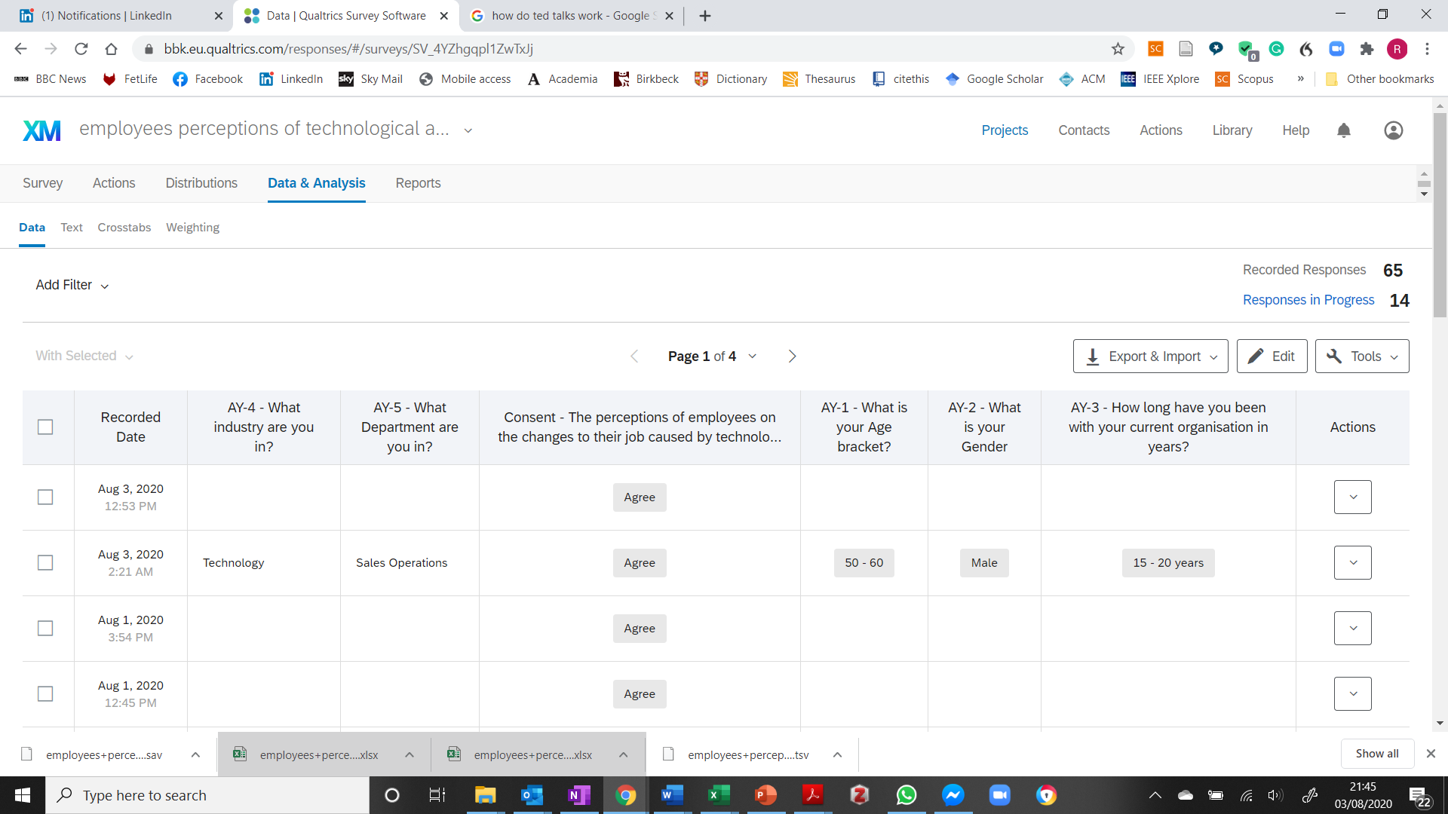

### 10.5.2 Number of completed and uncompleted surveys

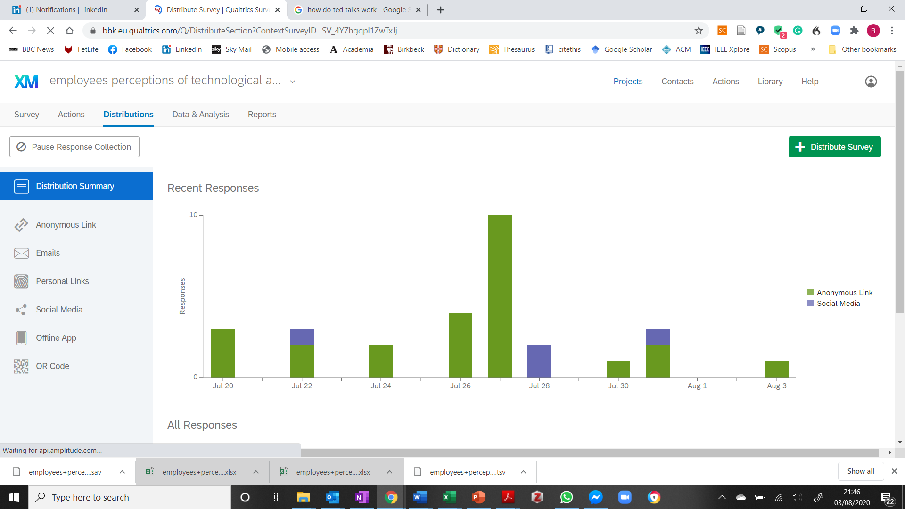

## 10.6 Appendix 6 – Raw data (Quantitative)





















## 10.7 Appendix 7 - Data analysis

(Log or Syntax file showing all Analysis)

GET

FILE='C:\Users\rober\Documents\Master Degree\Thesis\09 -Thesis\04 - Collected Data/employees+perceptions+of+technological+automation_August+9,+2020_05.06.sav'.

DATASET NAME DataSet3 WINDOW=FRONT.

RECODE TY_2 (2=0) (1=1) INTO TY_1_1.

EXECUTE.

USE ALL.

COMPUTE filter_$=(Finished = 0).

VARIABLE LABELS filter_$ 'Finished = 0 (FILTER)'.

VALUE LABELS filter_$ 0 'Not Selected' 1 'Selected'.

FORMATS filter_$ (f1.0).

FILTER BY filter_$.

EXECUTE.

USE ALL.

COMPUTE filter_$=(Finished = 1).

VARIABLE LABELS filter_$ 'Finished = 1 (FILTER)'.

VALUE LABELS filter_$ 0 'Not Selected' 1 'Selected'.

FORMATS filter_$ (f1.0).

FILTER BY filter_$.

EXECUTE.

CORRELATIONS

/VARIABLES=AY_1 AY_2 AY_3 AY_6 GI_1 GI_2 GI_3 GI_4 YW_1 YW_2 YW_3 TY_1 TY_2 TY_3 TY_4 TY_5 TA_1

TA_2 TA_3 TA_4

/PRINT=TWOTAIL NOSIG

/STATISTICS DESCRIPTIVES

/MISSING=PAIRWISE.

**Correlations**

|  |  |  |
| --- | --- | --- |
| **Notes** | | |
| Output Created | | 10-SEP-2020 18:37:39 |
| Comments | |  |
| Input | Data | C:\Users\rober\Documents\Master Degree\Thesis\09 -Thesis\04 - Collected Data\employees+perceptions+of+technological+automation_August+9,+2020_05.06.sav |
| Active Dataset | DataSet3 |
| Filter | Finished = 1 (FILTER) |
| Weight | <none> |
| Split File | <none> |
| N of Rows in Working Data File | 60 |
| Missing Value Handling | Definition of Missing | User-defined missing values are treated as missing. |
| Cases Used | Statistics for each pair of variables are based on all the cases with valid data for that pair. |
| Syntax | | CORRELATIONS  /VARIABLES=AY_1 AY_2 AY_3 AY_6 GI_1 GI_2 GI_3 GI_4 YW_1 YW_2 YW_3 TY_1 TY_2 TY_3 TY_4 TY_5 TA_1  TA_2 TA_3 TA_4  /PRINT=TWOTAIL NOSIG  /STATISTICS DESCRIPTIVES  /MISSING=PAIRWISE. |
| Resources | Processor Time | 00:00:00.08 |
| Elapsed Time | 00:00:00.34 |

[DataSet3] C:\Users\rober\Documents\Master Degree\Thesis\09 -Thesis\04 - Collected Data\employees+perceptions+of+technological+automation_August+9,+2020_05.06.sav

|  |  |  |  |
| --- | --- | --- | --- |
| **Descriptive Statistics** | | | |
|  | Mean | Std. Deviation | N |
| What  is your Age bracket? | 3.33 | .951 | 60 |
| What is your Gender | 1.45 | .502 | 60 |
| How long have you been with your current organisation in years? | 2.50 | 1.918 | 60 |
| How  many people do you manage? | 1.62 | .846 | 60 |
| In general, how much do you think you know about technological automation? | 2.02 | .770 | 60 |
| Do you think technological automation is a good thing? | 1.05 | .218 | 41 |
| Does the future of technological automation give rise to concern for you? | 1.48 | .504 | 54 |
| Do you think that technological automation makes your life easier or more challenging? | 2.51 | .898 | 59 |
| Do you think that technological automation will change the office environment? | 1.06 | .242 | 49 |
| Do you feel that you receive enough training on new automated technological systems? | 1.87 | .833 | 60 |
| Do  you feel that management explain technological changes to you? | 2.22 | .811 | 59 |
| Have  computer automation changed the number of tasks you complete during a working  week, in the last year? | 1.45 | .503 | 51 |
| Do you perceive that technological automation will change the tasks you perform during a working week, in the next year? | 1.40 | .495 | 52 |
| How much time do you perceive you spend on computers in an average week? (In hours, 35 hour week) | 3.18 | .983 | 60 |
| Please estimate the number of tasks you perform, without the aid of a computer per week (Excluding meetings and or talking to people)? | 1.37 | .802 | 60 |
| Please estimate the number of tasks you perform with the aid of a computer per week? | 2.25 | 1.052 | 60 |
| How prepared if at all, do you think your employer is when adopting new computer automaton? | 1.92 | .731 | 49 |
| My job is almost guaranteed/a permanent position is there if I want it | 1.42 | .645 | 60 |
| My job feels secure | 1.35 | .547 | 60 |
| Does your organisation implementing new technological automation give you optimism for our continued job security? | 1.35 | .482 | 46 |

**Hypothasis One**

CROSSTABS

/TABLES=TA_3 BY TY_1

/FORMAT=AVALUE TABLES

/STATISTICS=CHISQ CC

/CELLS=COUNT EXPECTED ROW

/COUNT ROUND CELL

/BARCHART.

**Crosstabs**

|  |  |  |
| --- | --- | --- |
| **Notes** | | |
| Output Created | | 10-SEP-2020 18:39:38 |
| Comments | |  |
| Input | Data | C:\Users\rober\Documents\Master Degree\Thesis\09 -Thesis\04 - Collected Data\employees+perceptions+of+technological+automation_August+9,+2020_05.06.sav |
| Active Dataset | DataSet3 |
| Filter | Finished = 1 (FILTER) |
| Weight | <none> |
| Split File | <none> |
| N of Rows in Working Data File | 60 |
| Missing Value Handling | Definition of Missing | User-defined missing values are treated as missing. |
| Cases Used | Statistics for each table are based on all the cases with valid data in the specified range(s) for all variables in each table. |
| Syntax | | CROSSTABS  /TABLES=TA_3 BY TY_1  /FORMAT=AVALUE TABLES  /STATISTICS=CHISQ CC  /CELLS=COUNT EXPECTED ROW  /COUNT ROUND CELL  /BARCHART. |
| Resources | Processor Time | 00:00:05.67 |
| Elapsed Time | 00:00:04.39 |
| Dimensions Requested | 2 |
| Cells Available | 524245 |

|  |  |  |  |  |  |  |
| --- | --- | --- | --- | --- | --- | --- |
| **Case Processing Summary** | | | | | | |
|  | Cases | | | | | |
| Valid | | Missing | | Total | |
| N | Percent | N | Percent | N | Percent |
| My job feels secure * Have  computer automation changed the number of tasks you complete during a working  week, in the last year? | 51 | 85.0% | 9 | 15.0% | 60 | 100.0% |

|  |  |  |  |  |  |
| --- | --- | --- | --- | --- | --- |
| **My job feels secure * Have**  **computer automation changed the number of tasks you complete during a working**  **week, in the last year? Crosstabulation** | | | | | |
|  | | | Have  computer automation changed the number of tasks you complete during a working  week, in the last year? | | Total |
| Yes | No |
| My job feels secure | Agree | Count | 19 | 19 | 38 |
| Expected Count | 20.9 | 17.1 | 38.0 |
| % within My job feels secure | 50.0% | 50.0% | 100.0% |
| Disagree | Count | 8 | 4 | 12 |
| Expected Count | 6.6 | 5.4 | 12.0 |
| % within My job feels secure | 66.7% | 33.3% | 100.0% |
| Don't Know | Count | 1 | 0 | 1 |
| Expected Count | .5 | .5 | 1.0 |
| % within My job feels secure | 100.0% | 0.0% | 100.0% |
| Total | | Count | 28 | 23 | 51 |
| Expected Count | 28.0 | 23.0 | 51.0 |
| % within My job feels secure | 54.9% | 45.1% | 100.0% |

|  |  |  |  |
| --- | --- | --- | --- |
| **Chi-Square Tests** | | | |
|  | Value | df | Asymptotic Significance (2-sided) |
| Pearson Chi-Square | 1.861a | 2 | .394 |
| Likelihood Ratio | 2.255 | 2 | .324 |
| Linear-by-Linear Association | 1.744 | 1 | .187 |
| N of Valid Cases | 51 |  |  |
| a. 2 cells (33.3%) have expected count less than 5. The minimum expected count is .45. | | | |

|  |  |  |  |
| --- | --- | --- | --- |
| **Symmetric Measures** | | | |
|  | | Value | Approximate Significance |
| Nominal by Nominal | Contingency Coefficient | .188 | .394 |
| N of Valid Cases | | 51 |  |

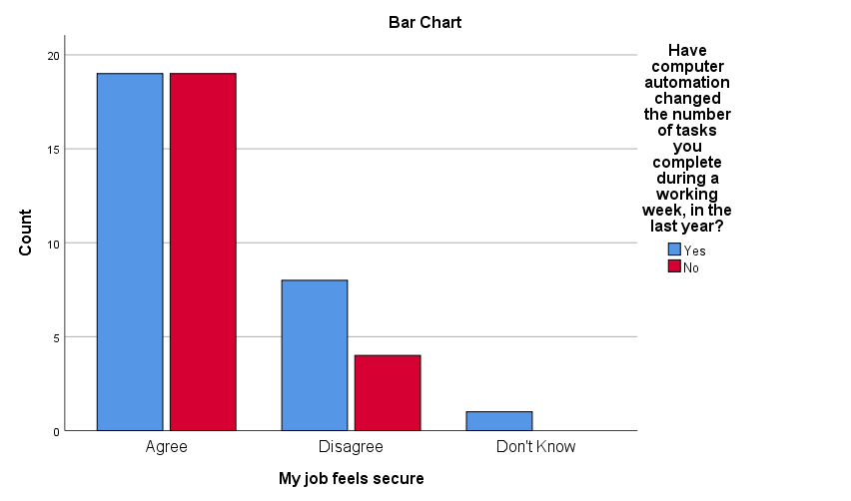

CROSSTABS

/TABLES=TY_1 BY GI_3

/FORMAT=AVALUE TABLES

/STATISTICS=CHISQ CC

/CELLS=COUNT EXPECTED ROW

/COUNT ROUND CELL

/BARCHART.

**Crosstabs**

|  |  |  |
| --- | --- | --- |
| **Notes** | | |
| Output Created | | 10-SEP-2020 18:43:44 |
| Comments | |  |
| Input | Data | C:\Users\rober\Documents\Master Degree\Thesis\09 -Thesis\04 - Collected Data\employees+perceptions+of+technological+automation_August+9,+2020_05.06.sav |
| Active Dataset | DataSet3 |
| Filter | Finished = 1 (FILTER) |
| Weight | <none> |
| Split File | <none> |
| N of Rows in Working Data File | 60 |
| Missing Value Handling | Definition of Missing | User-defined missing values are treated as missing. |
| Cases Used | Statistics for each table are based on all the cases with valid data in the specified range(s) for all variables in each table. |
| Syntax | | CROSSTABS  /TABLES=TY_1 BY GI_3  /FORMAT=AVALUE TABLES  /STATISTICS=CHISQ CC  /CELLS=COUNT EXPECTED ROW  /COUNT ROUND CELL  /BARCHART. |
| Resources | Processor Time | 00:00:02.53 |
| Elapsed Time | 00:00:01.93 |
| Dimensions Requested | 2 |
| Cells Available | 524245 |

|  |  |  |  |  |  |  |
| --- | --- | --- | --- | --- | --- | --- |
| **Case Processing Summary** | | | | | | |
|  | Cases | | | | | |
| Valid | | Missing | | Total | |
| N | Percent | N | Percent | N | Percent |
| Have  computer automation changed the number of tasks you complete during a working  week, in the last year? * Does the future of technological automation give rise to concern for you? | 47 | 78.3% | 13 | 21.7% | 60 | 100.0% |

|  |  |  |  |  |  |
| --- | --- | --- | --- | --- | --- |
| **Have**  **computer automation changed the number of tasks you complete during a working**  **week, in the last year? * Does the future of technological automation give rise to concern for you? Crosstabulation** | | | | | |
|  | | | Does the future of technological automation give rise to concern for you? | | Total |
| Yes | No |
| Have  computer automation changed the number of tasks you complete during a working  week, in the last year? | Yes | Count | 18 | 9 | 27 |
| Expected Count | 13.8 | 13.2 | 27.0 |
| % within Have  computer automation changed the number of tasks you complete during a working  week, in the last year? | 66.7% | 33.3% | 100.0% |
| No | Count | 6 | 14 | 20 |
| Expected Count | 10.2 | 9.8 | 20.0 |
| % within Have  computer automation changed the number of tasks you complete during a working  week, in the last year? | 30.0% | 70.0% | 100.0% |
| Total | | Count | 24 | 23 | 47 |
| Expected Count | 24.0 | 23.0 | 47.0 |
| % within Have  computer automation changed the number of tasks you complete during a working  week, in the last year? | 51.1% | 48.9% | 100.0% |

|  |  |  |  |  |  |
| --- | --- | --- | --- | --- | --- |
| **Chi-Square Tests** | | | | | |
|  | Value | df | Asymptotic Significance (2-sided) | Exact Sig. (2-sided) | Exact Sig. (1-sided) |
| Pearson Chi-Square | 6.182a | 1 | .013 |  |  |
| Continuity Correctionb | 4.801 | 1 | .028 |  |  |
| Likelihood Ratio | 6.328 | 1 | .012 |  |  |
| Fisher's Exact Test |  |  |  | .019 | .014 |
| Linear-by-Linear Association | 6.050 | 1 | .014 |  |  |
| N of Valid Cases | 47 |  |  |  |  |
| a. 0 cells (.0%) have expected count less than 5. The minimum expected count is 9.79. | | | | | |
| b. Computed only for a 2x2 table | | | | | |

|  |  |  |  |
| --- | --- | --- | --- |
| **Symmetric Measures** | | | |
|  | | Value | Approximate Significance |
| Nominal by Nominal | Contingency Coefficient | .341 | .013 |
| N of Valid Cases | | 47 |  |

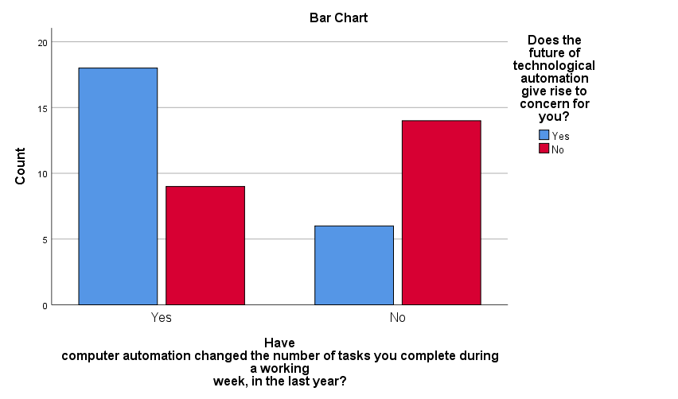

CROSSTABS

/TABLES=TA_2 BY TY_1

/FORMAT=AVALUE TABLES

/STATISTICS=CHISQ CC

/CELLS=COUNT EXPECTED ROW

/COUNT ROUND CELL

/BARCHART.

**Crosstabs**

|  |  |  |
| --- | --- | --- |
| **Notes** | | |
| Output Created | | 10-SEP-2020 18:47:03 |
| Comments | |  |
| Input | Data | C:\Users\rober\Documents\Master Degree\Thesis\09 -Thesis\04 - Collected Data\employees+perceptions+of+technological+automation_August+9,+2020_05.06.sav |
| Active Dataset | DataSet3 |
| Filter | Finished = 1 (FILTER) |
| Weight | <none> |
| Split File | <none> |
| N of Rows in Working Data File | 60 |
| Missing Value Handling | Definition of Missing | User-defined missing values are treated as missing. |
| Cases Used | Statistics for each table are based on all the cases with valid data in the specified range(s) for all variables in each table. |
| Syntax | | CROSSTABS  /TABLES=TA_2 BY TY_1  /FORMAT=AVALUE TABLES  /STATISTICS=CHISQ CC  /CELLS=COUNT EXPECTED ROW  /COUNT ROUND CELL  /BARCHART. |
| Resources | Processor Time | 00:00:00.80 |
| Elapsed Time | 00:00:00.74 |
| Dimensions Requested | 2 |
| Cells Available | 524245 |

|  |  |  |  |  |  |  |
| --- | --- | --- | --- | --- | --- | --- |
| **Case Processing Summary** | | | | | | |
|  | Cases | | | | | |
| Valid | | Missing | | Total | |
| N | Percent | N | Percent | N | Percent |
| My job is almost guaranteed/a permanent position is there if I want it * Have  computer automation changed the number of tasks you complete during a working  week, in the last year? | 51 | 85.0% | 9 | 15.0% | 60 | 100.0% |

|  |  |  |  |  |  |
| --- | --- | --- | --- | --- | --- |
| **My job is almost guaranteed/a permanent position is there if I want it * Have**  **computer automation changed the number of tasks you complete during a working**  **week, in the last year? Crosstabulation** | | | | | |
|  | | | Have  computer automation changed the number of tasks you complete during a working  week, in the last year? | | Total |
| Yes | No |
| My job is almost guaranteed/a permanent position is there if I want it | Agree | Count | 19 | 17 | 36 |
| Expected Count | 19.8 | 16.2 | 36.0 |
| % within My job is almost guaranteed/a permanent position is there if I want it | 52.8% | 47.2% | 100.0% |
| Disagree | Count | 8 | 4 | 12 |
| Expected Count | 6.6 | 5.4 | 12.0 |
| % within My job is almost guaranteed/a permanent position is there if I want it | 66.7% | 33.3% | 100.0% |
| Don't Know | Count | 1 | 2 | 3 |
| Expected Count | 1.6 | 1.4 | 3.0 |
| % within My job is almost guaranteed/a permanent position is there if I want it | 33.3% | 66.7% | 100.0% |
| Total | | Count | 28 | 23 | 51 |
| Expected Count | 28.0 | 23.0 | 51.0 |
| % within My job is almost guaranteed/a permanent position is there if I want it | 54.9% | 45.1% | 100.0% |

|  |  |  |  |
| --- | --- | --- | --- |
| **Chi-Square Tests** | | | |
|  | Value | df | Asymptotic Significance (2-sided) |
| Pearson Chi-Square | 1.300a | 2 | .522 |
| Likelihood Ratio | 1.319 | 2 | .517 |
| Linear-by-Linear Association | .003 | 1 | .956 |
| N of Valid Cases | 51 |  |  |
| a. 2 cells (33.3%) have expected count less than 5. The minimum expected count is 1.35. | | | |

|  |  |  |  |
| --- | --- | --- | --- |
| **Symmetric Measures** | | | |
|  | | Value | Approximate Significance |
| Nominal by Nominal | Contingency Coefficient | .158 | .522 |
| N of Valid Cases | | 51 |  |

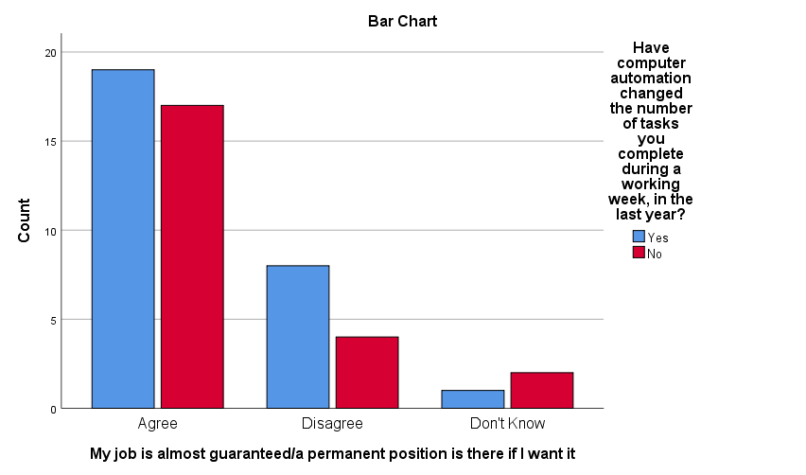

CROSSTABS

/TABLES=TY_1 BY TA_4

/FORMAT=AVALUE TABLES

/STATISTICS=CHISQ CC

/CELLS=COUNT EXPECTED ROW

/COUNT ROUND CELL

/BARCHART.

**Crosstabs**

|  |  |  |
| --- | --- | --- |
| **Notes** | | |
| Output Created | | 10-SEP-2020 18:48:14 |
| Comments | |  |
| Input | Data | C:\Users\rober\Documents\Master Degree\Thesis\09 -Thesis\04 - Collected Data\employees+perceptions+of+technological+automation_August+9,+2020_05.06.sav |
| Active Dataset | DataSet3 |
| Filter | Finished = 1 (FILTER) |
| Weight | <none> |
| Split File | <none> |
| N of Rows in Working Data File | 60 |
| Missing Value Handling | Definition of Missing | User-defined missing values are treated as missing. |
| Cases Used | Statistics for each table are based on all the cases with valid data in the specified range(s) for all variables in each table. |
| Syntax | | CROSSTABS  /TABLES=TY_1 BY TA_4  /FORMAT=AVALUE TABLES  /STATISTICS=CHISQ CC  /CELLS=COUNT EXPECTED ROW  /COUNT ROUND CELL  /BARCHART. |
| Resources | Processor Time | 00:00:00.80 |
| Elapsed Time | 00:00:00.77 |
| Dimensions Requested | 2 |
| Cells Available | 524245 |

|  |  |  |  |  |  |  |  |
| --- | --- | --- | --- | --- | --- | --- | --- |
| **Case Processing Summary** | | | | | | | |
|  | Cases | | | | | | |
| Valid | | Missing | | Total | |
| N | Percent | N | Percent | N | Percent |
| Have  computer automation changed the number of tasks you complete during a working  week, in the last year? * Does your organisation implementing new technological automation give you optimism for our continued job security? | 41 | 68.3% | 19 | 31.7% | 60 | 100.0% |

|  |  |  |  |  |  |
| --- | --- | --- | --- | --- | --- |
| **Have**  **computer automation changed the number of tasks you complete during a working**  **week, in the last year? * Does your organisation implementing new technological automation give you optimism for our continued job security? Crosstabulation** | | | | | |
|  | | | Does your organisation implementing new technological automation give you optimism for our continued job security? | | Total |
| Yes | No |
| Have  computer automation changed the number of tasks you complete during a working  week, in the last year? | Yes | Count | 18 | 8 | 26 |
| Expected Count | 17.8 | 8.2 | 26.0 |
| % within Have  computer automation changed the number of tasks you complete during a working  week, in the last year? | 69.2% | 30.8% | 100.0% |
| No | Count | 10 | 5 | 15 |
| Expected Count | 10.2 | 4.8 | 15.0 |
| % within Have  computer automation changed the number of tasks you complete during a working  week, in the last year? | 66.7% | 33.3% | 100.0% |
| Total | | Count | 28 | 13 | 41 |
| Expected Count | 28.0 | 13.0 | 41.0 |
| % within Have  computer automation changed the number of tasks you complete during a working  week, in the last year? | 68.3% | 31.7% | 100.0% |

|  |  |  |  |  |  |
| --- | --- | --- | --- | --- | --- |
| **Chi-Square Tests** | | | | | |
|  | Value | df | Asymptotic Significance (2-sided) | Exact Sig. (2-sided) | Exact Sig. (1-sided) |
| Pearson Chi-Square | .029a | 1 | .865 |  |  |
| Continuity Correctionb | .000 | 1 | 1.000 |  |  |
| Likelihood Ratio | .029 | 1 | .865 |  |  |
| Fisher's Exact Test |  |  |  | 1.000 | .566 |
| Linear-by-Linear Association | .028 | 1 | .867 |  |  |
| N of Valid Cases | 41 |  |  |  |  |
| a. 1 cells (25.0%) have expected count less than 5. The minimum expected count is 4.76. | | | | | |
| b. Computed only for a 2x2 table | | | | | |

|  |  |  |  |
| --- | --- | --- | --- |
| **Symmetric Measures** | | | |
|  | | Value | Approximate Significance |
| Nominal by Nominal | Contingency Coefficient | .027 | .865 |
| N of Valid Cases | | 41 |  |

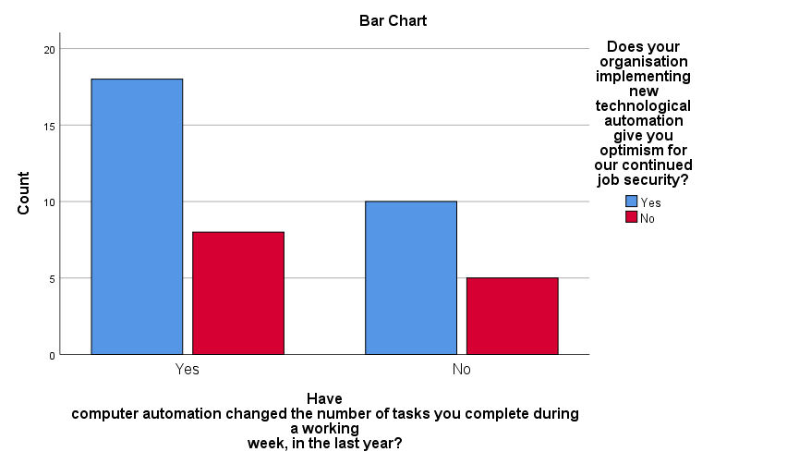

**Hypothasis Two**

CROSSTABS

/TABLES=TA_3 BY TY_2

/FORMAT=AVALUE TABLES

/STATISTICS=CHISQ CC

/CELLS=COUNT EXPECTED ROW

/COUNT ROUND CELL

/BARCHART.

**Crosstabs**

|  |  |  |
| --- | --- | --- |
| **Notes** | | |
| Output Created | | 10-SEP-2020 18:56:53 |
| Comments | |  |
| Input | Data | C:\Users\rober\Documents\Master Degree\Thesis\09 -Thesis\04 - Collected Data\employees+perceptions+of+technological+automation_August+9,+2020_05.06.sav |
| Active Dataset | DataSet3 |
| Filter | Finished = 1 (FILTER) |
| Weight | <none> |
| Split File | <none> |
| N of Rows in Working Data File | 60 |
| Missing Value Handling | Definition of Missing | User-defined missing values are treated as missing. |
| Cases Used | Statistics for each table are based on all the cases with valid data in the specified range(s) for all variables in each table. |
| Syntax | | CROSSTABS  /TABLES=TA_3 BY TY_2  /FORMAT=AVALUE TABLES  /STATISTICS=CHISQ CC  /CELLS=COUNT EXPECTED ROW  /COUNT ROUND CELL  /BARCHART. |
| Resources | Processor Time | 00:00:00.66 |
| Elapsed Time | 00:00:00.67 |
| Dimensions Requested | 2 |
| Cells Available | 524245 |

|  |  |  |  |  |  |  |
| --- | --- | --- | --- | --- | --- | --- |
| **Case Processing Summary** | | | | | | |
|  | Cases | | | | | |
| Valid | | Missing | | Total | |
| N | Percent | N | Percent | N | Percent |
| My job feels secure * Do you perceive that technological automation will change the tasks you perform during a working week, in the next year? | 52 | 86.7% | 8 | 13.3% | 60 | 100.0% |

|  |  |  |  |  |  |
| --- | --- | --- | --- | --- | --- |
| **My job feels secure * Do you perceive that technological automation will change the tasks you perform during a working week, in the next year? Crosstabulation** | | | | | |
|  | | | Do you perceive that technological automation will change the tasks you perform during a working week, in the next year? | | Total |
| Yes | No |
| My job feels secure | Agree | Count | 19 | 17 | 36 |
| Expected Count | 21.5 | 14.5 | 36.0 |
| % within My job feels secure | 52.8% | 47.2% | 100.0% |
| Disagree | Count | 12 | 4 | 16 |
| Expected Count | 9.5 | 6.5 | 16.0 |
| % within My job feels secure | 75.0% | 25.0% | 100.0% |
| Total | | Count | 31 | 21 | 52 |
| Expected Count | 31.0 | 21.0 | 52.0 |
| % within My job feels secure | 59.6% | 40.4% | 100.0% |

|  |  |  |  |  |  |
| --- | --- | --- | --- | --- | --- |
| **Chi-Square Tests** | | | | | |
|  | Value | df | Asymptotic Significance (2-sided) | Exact Sig. (2-sided) | Exact Sig. (1-sided) |
| Pearson Chi-Square | 2.272a | 1 | .132 |  |  |
| Continuity Correctionb | 1.443 | 1 | .230 |  |  |
| Likelihood Ratio | 2.362 | 1 | .124 |  |  |
| Fisher's Exact Test |  |  |  | .220 | .114 |
| Linear-by-Linear Association | 2.228 | 1 | .135 |  |  |
| N of Valid Cases | 52 |  |  |  |  |
| a. 0 cells (.0%) have expected count less than 5. The minimum expected count is 6.46. | | | | | |
| b. Computed only for a 2x2 table | | | | | |

|  |  |  |  |
| --- | --- | --- | --- |
| **Symmetric Measures** | | | |
|  | | Value | Approximate Significance |
| Nominal by Nominal | Contingency Coefficient | .205 | .132 |
| N of Valid Cases | | 52 |  |

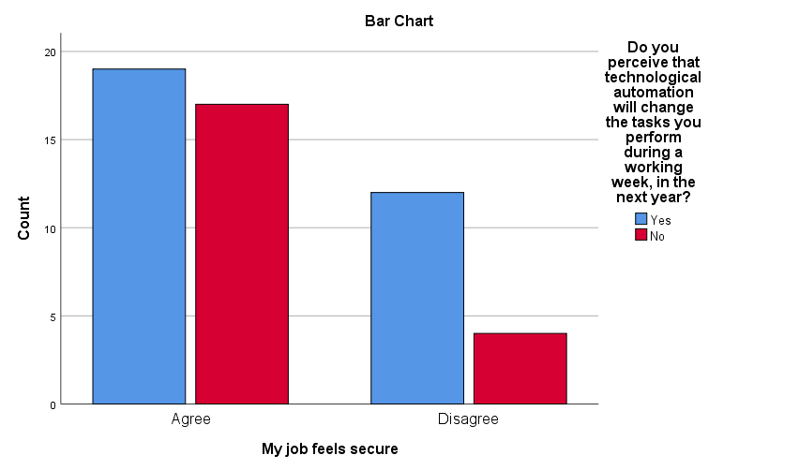

CROSSTABS

/TABLES=TY_2 BY GI_3

/FORMAT=AVALUE TABLES

/STATISTICS=CHISQ CC

/CELLS=COUNT EXPECTED ROW

/COUNT ROUND CELL

/BARCHART.

**Crosstabs**

|  |  |  |
| --- | --- | --- |
| **Notes** | | |
| Output Created | | 10-SEP-2020 19:09:01 |
| Comments | |  |
| Input | Data | C:\Users\rober\Documents\Master Degree\Thesis\09 -Thesis\04 - Collected Data\employees+perceptions+of+technological+automation_August+9,+2020_05.06.sav |
| Active Dataset | DataSet3 |
| Filter | Finished = 1 (FILTER) |
| Weight | <none> |
| Split File | <none> |
| N of Rows in Working Data File | 60 |
| Missing Value Handling | Definition of Missing | User-defined missing values are treated as missing. |
| Cases Used | Statistics for each table are based on all the cases with valid data in the specified range(s) for all variables in each table. |
| Syntax | | CROSSTABS  /TABLES=TY_2 BY GI_3  /FORMAT=AVALUE TABLES  /STATISTICS=CHISQ CC  /CELLS=COUNT EXPECTED ROW  /COUNT ROUND CELL  /BARCHART. |
| Resources | Processor Time | 00:00:00.56 |
| Elapsed Time | 00:00:00.74 |
| Dimensions Requested | 2 |
| Cells Available | 524245 |

|  |  |  |  |  |  |  |
| --- | --- | --- | --- | --- | --- | --- |
| **Case Processing Summary** | | | | | | |
|  | Cases | | | | | |
| Valid | | Missing | | Total | |
| N | Percent | N | Percent | N | Percent |
| Do you perceive that technological automation will change the tasks you perform during a working week, in the next year? * Does the future of technological automation give rise to concern for you? | 50 | 83.3% | 10 | 16.7% | 60 | 100.0% |

|  |  |  |  |  |  |
| --- | --- | --- | --- | --- | --- |
| **Do you perceive that technological automation will change the tasks you perform during a working week, in the next year? * Does the future of technological automation give rise to concern for you? Crosstabulation** | | | | | |
|  | | | Does the future of technological automation give rise to concern for you? | | Total |
| Yes | No |
| Do you perceive that technological automation will change the tasks you perform during a working week, in the next year? | Yes | Count | 21 | 10 | 31 |
| Expected Count | 16.1 | 14.9 | 31.0 |
| % within Do you perceive that technological automation will change the tasks you perform during a working week, in the next year? | 67.7% | 32.3% | 100.0% |
| No | Count | 5 | 14 | 19 |
| Expected Count | 9.9 | 9.1 | 19.0 |
| % within Do you perceive that technological automation will change the tasks you perform during a working week, in the next year? | 26.3% | 73.7% | 100.0% |
| Total | | Count | 26 | 24 | 50 |
| Expected Count | 26.0 | 24.0 | 50.0 |
| % within Do you perceive that technological automation will change the tasks you perform during a working week, in the next year? | 52.0% | 48.0% | 100.0% |

|  |  |  |  |  |  |
| --- | --- | --- | --- | --- | --- |
| **Chi-Square Tests** | | | | | |
|  | Value | df | Asymptotic Significance (2-sided) | Exact Sig. (2-sided) | Exact Sig. (1-sided) |
| Pearson Chi-Square | 8.099a | 1 | .004 |  |  |
| Continuity Correctionb | 6.525 | 1 | .011 |  |  |
| Likelihood Ratio | 8.348 | 1 | .004 |  |  |
| Fisher's Exact Test |  |  |  | .008 | .005 |
| Linear-by-Linear Association | 7.937 | 1 | .005 |  |  |
| N of Valid Cases | 50 |  |  |  |  |
| a. 0 cells (.0%) have expected count less than 5. The minimum expected count is 9.12. | | | | | |
| b. Computed only for a 2x2 table | | | | | |

|  |  |  |  |
| --- | --- | --- | --- |
| **Symmetric Measures** | | | |
|  | | Value | Approximate Significance |
| Nominal by Nominal | Contingency Coefficient | .373 | .004 |
| N of Valid Cases | | 50 |  |

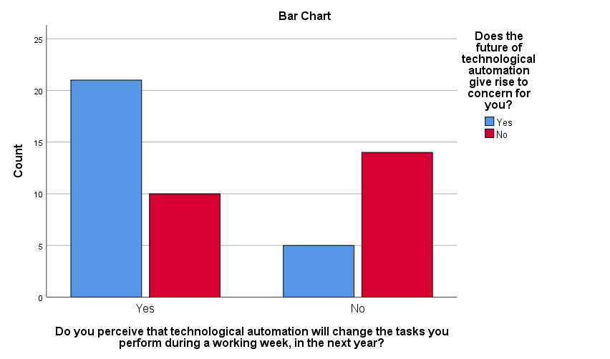

CROSSTABS

/TABLES=TA_2 BY TY_2

/FORMAT=AVALUE TABLES

/STATISTICS=CHISQ CC

/CELLS=COUNT EXPECTED ROW

/COUNT ROUND CELL

/BARCHART.

**Crosstabs**

|  |  |  |
| --- | --- | --- |
| **Notes** | | |
| Output Created | | 10-SEP-2020 19:10:06 |
| Comments | |  |
| Input | Data | C:\Users\rober\Documents\Master Degree\Thesis\09 -Thesis\04 - Collected Data\employees+perceptions+of+technological+automation_August+9,+2020_05.06.sav |
| Active Dataset | DataSet3 |
| Filter | Finished = 1 (FILTER) |
| Weight | <none> |
| Split File | <none> |
| N of Rows in Working Data File | 60 |
| Missing Value Handling | Definition of Missing | User-defined missing values are treated as missing. |
| Cases Used | Statistics for each table are based on all the cases with valid data in the specified range(s) for all variables in each table. |
| Syntax | | CROSSTABS  /TABLES=TA_2 BY TY_2  /FORMAT=AVALUE TABLES  /STATISTICS=CHISQ CC  /CELLS=COUNT EXPECTED ROW  /COUNT ROUND CELL  /BARCHART. |
| Resources | Processor Time | 00:00:00.86 |
| Elapsed Time | 00:00:01.20 |
| Dimensions Requested | 2 |
| Cells Available | 524245 |

|  |  |  |  |  |  |  |
| --- | --- | --- | --- | --- | --- | --- |
| **Case Processing Summary** | | | | | | |
|  | Cases | | | | | |
| Valid | | Missing | | Total | |
| N | Percent | N | Percent | N | Percent |
| My job is almost guaranteed/a permanent position is there if I want it * Do you perceive that technological automation will change the tasks you perform during a working week, in the next year? | 52 | 86.7% | 8 | 13.3% | 60 | 100.0% |

|  |  |  |  |  |  |
| --- | --- | --- | --- | --- | --- |
| **My job is almost guaranteed/a permanent position is there if I want it * Do you perceive that technological automation will change the tasks you perform during a working week, in the next year? Crosstabulation** | | | | | |
|  | | | Do you perceive that technological automation will change the tasks you perform during a working week, in the next year? | | Total |
| Yes | No |
| My job is almost guaranteed/a permanent position is there if I want it | Agree | Count | 19 | 15 | 34 |
| Expected Count | 20.3 | 13.7 | 34.0 |
| % within My job is almost guaranteed/a permanent position is there if I want it | 55.9% | 44.1% | 100.0% |
| Disagree | Count | 11 | 4 | 15 |
| Expected Count | 8.9 | 6.1 | 15.0 |
| % within My job is almost guaranteed/a permanent position is there if I want it | 73.3% | 26.7% | 100.0% |
| Don't Know | Count | 1 | 2 | 3 |
| Expected Count | 1.8 | 1.2 | 3.0 |
| % within My job is almost guaranteed/a permanent position is there if I want it | 33.3% | 66.7% | 100.0% |
| Total | | Count | 31 | 21 | 52 |
| Expected Count | 31.0 | 21.0 | 52.0 |
| % within My job is almost guaranteed/a permanent position is there if I want it | 59.6% | 40.4% | 100.0% |

|  |  |  |  |
| --- | --- | --- | --- |
| **Chi-Square Tests** | | | |
|  | Value | df | Asymptotic Significance (2-sided) |
| Pearson Chi-Square | 2.230a | 2 | .328 |
| Likelihood Ratio | 2.273 | 2 | .321 |
| Linear-by-Linear Association | .051 | 1 | .822 |
| N of Valid Cases | 52 |  |  |
| a. 2 cells (33.3%) have expected count less than 5. The minimum expected count is 1.21. | | | |

|  |  |  |  |
| --- | --- | --- | --- |
| **Symmetric Measures** | | | |
|  | | Value | Approximate Significance |
| Nominal by Nominal | Contingency Coefficient | .203 | .328 |
| N of Valid Cases | | 52 |  |

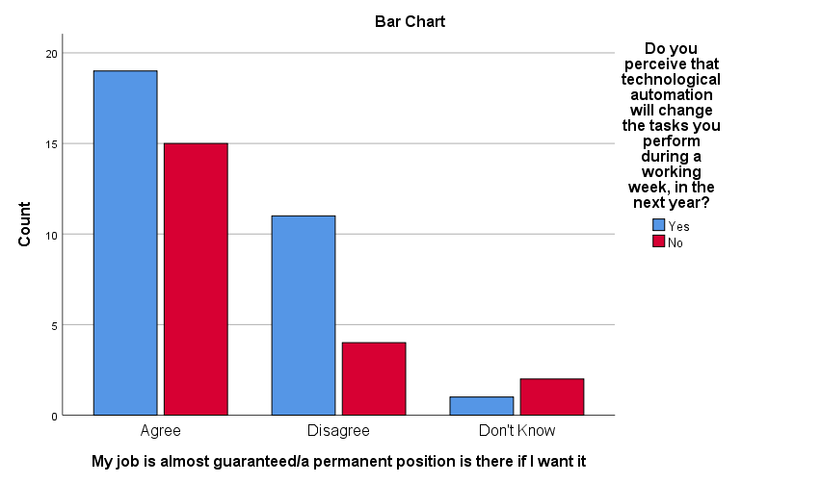

CROSSTABS

/TABLES=TA_4 BY TY_2

/FORMAT=AVALUE TABLES

/STATISTICS=CHISQ CC

/CELLS=COUNT EXPECTED ROW

/COUNT ROUND CELL

/BARCHART.

**Crosstabs**

|  |  |  |
| --- | --- | --- |
| **Notes** | | |
| Output Created | | 10-SEP-2020 19:10:50 |
| Comments | |  |
| Input | Data | C:\Users\rober\Documents\Master Degree\Thesis\09 -Thesis\04 - Collected Data\employees+perceptions+of+technological+automation_August+9,+2020_05.06.sav |
| Active Dataset | DataSet3 |
| Filter | Finished = 1 (FILTER) |
| Weight | <none> |
| Split File | <none> |
| N of Rows in Working Data File | 60 |
| Missing Value Handling | Definition of Missing | User-defined missing values are treated as missing. |
| Cases Used | Statistics for each table are based on all the cases with valid data in the specified range(s) for all variables in each table. |
| Syntax | | CROSSTABS  /TABLES=TA_4 BY TY_2  /FORMAT=AVALUE TABLES  /STATISTICS=CHISQ CC  /CELLS=COUNT EXPECTED ROW  /COUNT ROUND CELL  /BARCHART. |
| Resources | Processor Time | 00:00:00.55 |
| Elapsed Time | 00:00:01.11 |
| Dimensions Requested | 2 |
| Cells Available | 524245 |

|  |  |  |  |  |  |  |
| --- | --- | --- | --- | --- | --- | --- |
| **Case Processing Summary** | | | | | | |
|  | Cases | | | | | |
| Valid | | Missing | | Total | |
| N | Percent | N | Percent | N | Percent |
| Does your organisation implementing new technological automation give you optimism for our continued job security? * Do you perceive that technological automation will change the tasks you perform during a working week, in the next year? | 41 | 68.3% | 19 | 31.7% | 60 | 100.0% |

|  |  |  |  |  |  |
| --- | --- | --- | --- | --- | --- |
| **Does your organisation implementing new technological automation give you optimism for our continued job security? * Do you perceive that technological automation will change the tasks you perform during a working week, in the next year? Crosstabulation** | | | | | |
|  | | | Do you perceive that technological automation will change the tasks you perform during a working week, in the next year? | | Total |
| Yes | No |
| Does your organisation implementing new technological automation give you optimism for our continued job security? | Yes | Count | 18 | 8 | 26 |
| Expected Count | 17.8 | 8.2 | 26.0 |
| % within Does your organisation implementing new technological automation give you optimism for our continued job security? | 69.2% | 30.8% | 100.0% |
| No | Count | 10 | 5 | 15 |
| Expected Count | 10.2 | 4.8 | 15.0 |
| % within Does your organisation implementing new technological automation give you optimism for our continued job security? | 66.7% | 33.3% | 100.0% |
| Total | | Count | 28 | 13 | 41 |
| Expected Count | 28.0 | 13.0 | 41.0 |
| % within Does your organisation implementing new technological automation give you optimism for our continued job security? | 68.3% | 31.7% | 100.0% |

|  |  |  |  |  |  |
| --- | --- | --- | --- | --- | --- |
| **Chi-Square Tests** | | | | | |
|  | Value | df | Asymptotic Significance (2-sided) | Exact Sig. (2-sided) | Exact Sig. (1-sided) |
| Pearson Chi-Square | .029a | 1 | .865 |  |  |
| Continuity Correctionb | .000 | 1 | 1.000 |  |  |
| Likelihood Ratio | .029 | 1 | .865 |  |  |
| Fisher's Exact Test |  |  |  | 1.000 | .566 |
| Linear-by-Linear Association | .028 | 1 | .867 |  |  |
| N of Valid Cases | 41 |  |  |  |  |
| a. 1 cells (25.0%) have expected count less than 5. The minimum expected count is 4.76. | | | | | |
| b. Computed only for a 2x2 table | | | | | |

|  |  |  |  |
| --- | --- | --- | --- |
| **Symmetric Measures** | | | |
|  | | Value | Approximate Significance |
| Nominal by Nominal | Contingency Coefficient | .027 | .865 |
| N of Valid Cases | | 41 |  |

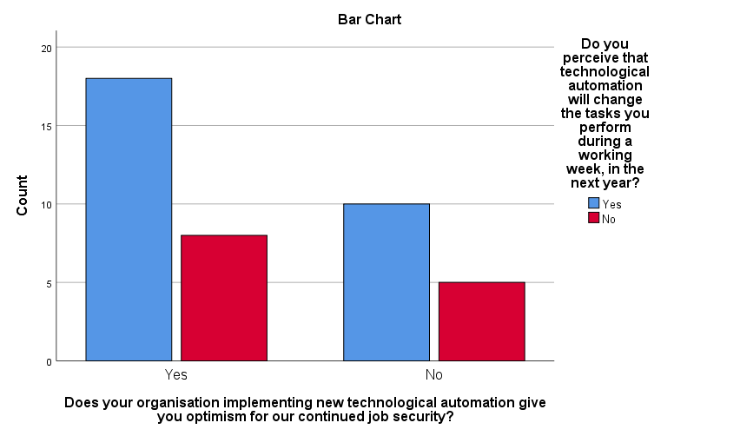

**Hypothasis Three**

CROSSTABS

/TABLES=TA_2 BY TA_3

/FORMAT=AVALUE TABLES

/STATISTICS=CHISQ CC

/CELLS=COUNT EXPECTED ROW

/COUNT ROUND CELL

/BARCHART.

**Crosstabs**

|  |  |  |
| --- | --- | --- |
| **Notes** | | |
| Output Created | | 10-SEP-2020 19:16:22 |
| Comments | |  |
| Input | Data | C:\Users\rober\Documents\Master Degree\Thesis\09 -Thesis\04 - Collected Data\employees+perceptions+of+technological+automation_August+9,+2020_05.06.sav |
| Active Dataset | DataSet3 |
| Filter | Finished = 1 (FILTER) |
| Weight | <none> |
| Split File | <none> |
| N of Rows in Working Data File | 60 |
| Missing Value Handling | Definition of Missing | User-defined missing values are treated as missing. |
| Cases Used | Statistics for each table are based on all the cases with valid data in the specified range(s) for all variables in each table. |
| Syntax | | CROSSTABS  /TABLES=TA_2 BY TA_3  /FORMAT=AVALUE TABLES  /STATISTICS=CHISQ CC  /CELLS=COUNT EXPECTED ROW  /COUNT ROUND CELL  /BARCHART. |
| Resources | Processor Time | 00:00:00.66 |
| Elapsed Time | 00:00:00.67 |
| Dimensions Requested | 2 |
| Cells Available | 524245 |

|  |  |  |  |  |  |  |
| --- | --- | --- | --- | --- | --- | --- |
| **Case Processing Summary** | | | | | | |
|  | Cases | | | | | |
| Valid | | Missing | | Total | |
| N | Percent | N | Percent | N | Percent |
| My job is almost guaranteed/a permanent position is there if I want it * My job feels secure | 60 | 100.0% | 0 | 0.0% | 60 | 100.0% |

|  |  |  |  |  |  |  |
| --- | --- | --- | --- | --- | --- | --- |
| **My job is almost guaranteed/a permanent position is there if I want it * My job feels secure Crosstabulation** | | | | | | |
|  | | | My job feels secure | | | Total |
| Agree | Disagree | Don't Know |
| My job is almost guaranteed/a permanent position is there if I want it | Agree | Count | 38 | 1 | 1 | 40 |
| Expected Count | 27.3 | 11.3 | 1.3 | 40.0 |
| % within My job is almost guaranteed/a permanent position is there if I want it | 95.0% | 2.5% | 2.5% | 100.0% |
| Disagree | Count | 1 | 14 | 0 | 15 |
| Expected Count | 10.3 | 4.3 | .5 | 15.0 |
| % within My job is almost guaranteed/a permanent position is there if I want it | 6.7% | 93.3% | 0.0% | 100.0% |
| Don't Know | Count | 2 | 2 | 1 | 5 |
| Expected Count | 3.4 | 1.4 | .2 | 5.0 |
| % within My job is almost guaranteed/a permanent position is there if I want it | 40.0% | 40.0% | 20.0% | 100.0% |
| Total | | Count | 41 | 17 | 2 | 60 |
| Expected Count | 41.0 | 17.0 | 2.0 | 60.0 |
| % within My job is almost guaranteed/a permanent position is there if I want it | 68.3% | 28.3% | 3.3% | 100.0% |

|  |  |  |  |
| --- | --- | --- | --- |
| **Chi-Square Tests** | | | |
|  | Value | df | Asymptotic Significance (2-sided) |
| Pearson Chi-Square | 49.877a | 4 | .000 |
| Likelihood Ratio | 51.156 | 4 | .000 |
| Linear-by-Linear Association | 23.873 | 1 | .000 |
| N of Valid Cases | 60 |  |  |
| a. 6 cells (66.7%) have expected count less than 5. The minimum expected count is .17. | | | |

|  |  |  |  |
| --- | --- | --- | --- |
| **Symmetric Measures** | | | |
|  | | Value | Approximate Significance |
| Nominal by Nominal | Contingency Coefficient | .674 | .000 |
| N of Valid Cases | | 60 |  |

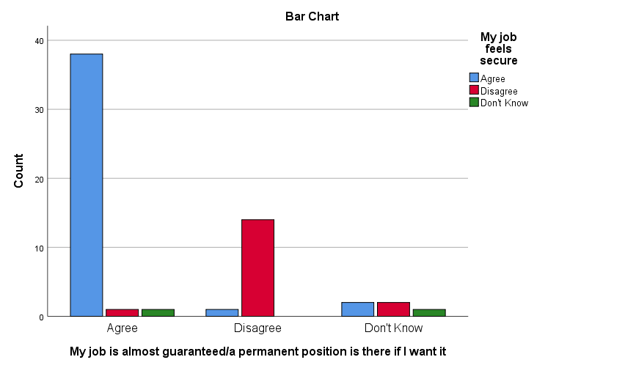

CROSSTABS

/TABLES=TA_2 BY GI_3

/FORMAT=AVALUE TABLES

/STATISTICS=CHISQ CC

/CELLS=COUNT EXPECTED ROW

/COUNT ROUND CELL

/BARCHART.

**Crosstabs**

|  |  |  |
| --- | --- | --- |
| **Notes** | | |
| Output Created | | 10-SEP-2020 19:17:36 |
| Comments | |  |
| Input | Data | C:\Users\rober\Documents\Master Degree\Thesis\09 -Thesis\04 - Collected Data\employees+perceptions+of+technological+automation_August+9,+2020_05.06.sav |
| Active Dataset | DataSet3 |
| Filter | Finished = 1 (FILTER) |
| Weight | <none> |
| Split File | <none> |
| N of Rows in Working Data File | 60 |
| Missing Value Handling | Definition of Missing | User-defined missing values are treated as missing. |
| Cases Used | Statistics for each table are based on all the cases with valid data in the specified range(s) for all variables in each table. |
| Syntax | | CROSSTABS  /TABLES=TA_2 BY GI_3  /FORMAT=AVALUE TABLES  /STATISTICS=CHISQ CC  /CELLS=COUNT EXPECTED ROW  /COUNT ROUND CELL  /BARCHART. |
| Resources | Processor Time | 00:00:00.49 |
| Elapsed Time | 00:00:00.66 |
| Dimensions Requested | 2 |
| Cells Available | 524245 |

|  |  |  |  |  |  |  |
| --- | --- | --- | --- | --- | --- | --- |
| **Case Processing Summary** | | | | | | |
|  | Cases | | | | | |
| Valid | | Missing | | Total | |
| N | Percent | N | Percent | N | Percent |
| My job is almost guaranteed/a permanent position is there if I want it * Does the future of technological automation give rise to concern for you? | 54 | 90.0% | 6 | 10.0% | 60 | 100.0% |

|  |  |  |  |  |  |
| --- | --- | --- | --- | --- | --- |
| **My job is almost guaranteed/a permanent position is there if I want it * Does the future of technological automation give rise to concern for you? Crosstabulation** | | | | | |
|  | | | Does the future of technological automation give rise to concern for you? | | Total |
| Yes | No |
| My job is almost guaranteed/a permanent position is there if I want it | Agree | Count | 15 | 21 | 36 |
| Expected Count | 18.7 | 17.3 | 36.0 |
| % within My job is almost guaranteed/a permanent position is there if I want it | 41.7% | 58.3% | 100.0% |
| Disagree | Count | 13 | 2 | 15 |
| Expected Count | 7.8 | 7.2 | 15.0 |
| % within My job is almost guaranteed/a permanent position is there if I want it | 86.7% | 13.3% | 100.0% |
| Don't Know | Count | 0 | 3 | 3 |
| Expected Count | 1.6 | 1.4 | 3.0 |
| % within My job is almost guaranteed/a permanent position is there if I want it | 0.0% | 100.0% | 100.0% |
| Total | | Count | 28 | 26 | 54 |
| Expected Count | 28.0 | 26.0 | 54.0 |
| % within My job is almost guaranteed/a permanent position is there if I want it | 51.9% | 48.1% | 100.0% |

|  |  |  |  |
| --- | --- | --- | --- |
| **Chi-Square Tests** | | | |
|  | Value | df | Asymptotic Significance (2-sided) |
| Pearson Chi-Square | 12.009a | 2 | .002 |
| Likelihood Ratio | 14.104 | 2 | .001 |
| Linear-by-Linear Association | .930 | 1 | .335 |
| N of Valid Cases | 54 |  |  |
| a. 2 cells (33.3%) have expected count less than 5. The minimum expected count is 1.44. | | | |

|  |  |  |  |
| --- | --- | --- | --- |
| **Symmetric Measures** | | | |
|  | | Value | Approximate Significance |
| Nominal by Nominal | Contingency Coefficient | .427 | .002 |
| N of Valid Cases | | 54 |  |

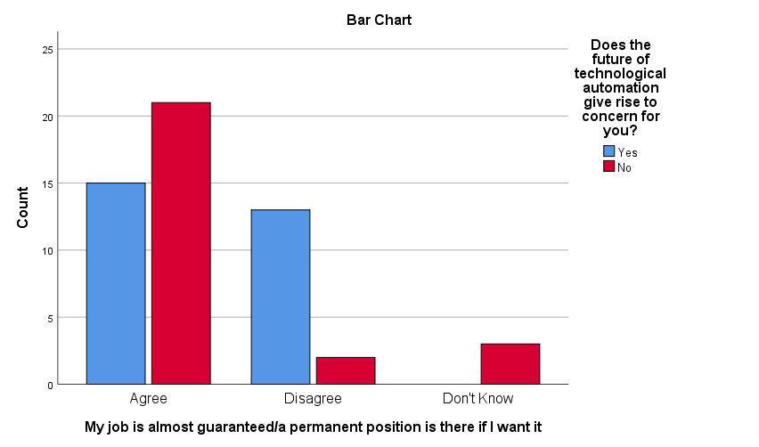

CROSSTABS

/TABLES=TA_2 BY TA_4

/FORMAT=AVALUE TABLES

/STATISTICS=CHISQ CC

/CELLS=COUNT EXPECTED ROW

/COUNT ROUND CELL

/BARCHART.

**Crosstabs**

|  |  |  |
| --- | --- | --- |
| **Notes** | | |
| Output Created | | 10-SEP-2020 19:18:17 |
| Comments | |  |
| Input | Data | C:\Users\rober\Documents\Master Degree\Thesis\09 -Thesis\04 - Collected Data\employees+perceptions+of+technological+automation_August+9,+2020_05.06.sav |
| Active Dataset | DataSet3 |
| Filter | Finished = 1 (FILTER) |
| Weight | <none> |
| Split File | <none> |
| N of Rows in Working Data File | 60 |
| Missing Value Handling | Definition of Missing | User-defined missing values are treated as missing. |
| Cases Used | Statistics for each table are based on all the cases with valid data in the specified range(s) for all variables in each table. |
| Syntax | | CROSSTABS  /TABLES=TA_2 BY TA_4  /FORMAT=AVALUE TABLES  /STATISTICS=CHISQ CC  /CELLS=COUNT EXPECTED ROW  /COUNT ROUND CELL  /BARCHART. |
| Resources | Processor Time | 00:00:00.92 |
| Elapsed Time | 00:00:01.52 |
| Dimensions Requested | 2 |
| Cells Available | 524245 |

|  |  |  |  |  |  |  |
| --- | --- | --- | --- | --- | --- | --- |
| **Case Processing Summary** | | | | | | |
|  | Cases | | | | | |
| Valid | | Missing | | Total | |
| N | Percent | N | Percent | N | Percent |
| My job is almost guaranteed/a permanent position is there if I want it * Does your organisation implementing new technological automation give you optimism for our continued job security? | 46 | 76.7% | 14 | 23.3% | 60 | 100.0% |

|  |  |  |  |  |  |
| --- | --- | --- | --- | --- | --- |
| **My job is almost guaranteed/a permanent position is there if I want it * Does your organisation implementing new technological automation give you optimism for our continued job security? Crosstabulation** | | | | | |
|  | | | Does your organisation implementing new technological automation give you optimism for our continued job security? | | Total |
| Yes | No |
| My job is almost guaranteed/a permanent position is there if I want it | Agree | Count | 27 | 5 | 32 |
| Expected Count | 20.9 | 11.1 | 32.0 |
| % within My job is almost guaranteed/a permanent position is there if I want it | 84.4% | 15.6% | 100.0% |
| Disagree | Count | 1 | 11 | 12 |
| Expected Count | 7.8 | 4.2 | 12.0 |
| % within My job is almost guaranteed/a permanent position is there if I want it | 8.3% | 91.7% | 100.0% |
| Don't Know | Count | 2 | 0 | 2 |
| Expected Count | 1.3 | .7 | 2.0 |
| % within My job is almost guaranteed/a permanent position is there if I want it | 100.0% | 0.0% | 100.0% |
| Total | | Count | 30 | 16 | 46 |
| Expected Count | 30.0 | 16.0 | 46.0 |
| % within My job is almost guaranteed/a permanent position is there if I want it | 65.2% | 34.8% | 100.0% |

|  |  |  |  |
| --- | --- | --- | --- |
| **Chi-Square Tests** | | | |
|  | Value | df | Asymptotic Significance (2-sided) |
| Pearson Chi-Square | 23.361a | 2 | .000 |
| Likelihood Ratio | 24.819 | 2 | .000 |
| Linear-by-Linear Association | 8.824 | 1 | .003 |
| N of Valid Cases | 46 |  |  |
| a. 3 cells (50.0%) have expected count less than 5. The minimum expected count is .70. | | | |

|  |  |  |  |
| --- | --- | --- | --- |
| **Symmetric Measures** | | | |
|  | | Value | Approximate Significance |
| Nominal by Nominal | Contingency Coefficient | .580 | .000 |
| N of Valid Cases | | 46 |  |

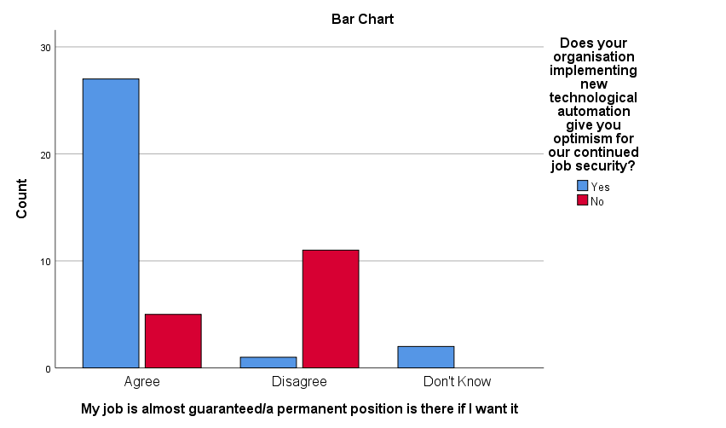

## 10.8 Appendix 8 – Pearson Correlation Matrix



\*\**p* <.005 \**p* <.001